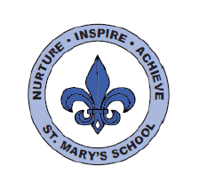
RWI
Dear Parents,
Your child is in ‘Yellow Group’
To date, your son/daughter will have learnt one way in which each long vowel sound is written (Set 2 sounds). When learning their Set 3 speed sounds they will be taught that there are more ways in which the same sounds are written, e.g. ‘ee’ as in tree and ‘ea’ as in tea. They will be working on ‘Yellow books’. These are more complex books including fiction and non-fiction titles which provide an opportunity to practise the new sounds they have learned. They will also be working on a range of writing tasks related to these books. There are 20 Set 3 ‘speed sounds’ that are made up of two or three letters which represent just one sound, e.g. ‘ea’ as in tea, ‘ow’ as in cow and ‘are’ as in care. These are also known as ‘digraphs’ or ‘trigraphs’. As before, it is important that your daughter/son does not pronounce these as 2 or 3 separate sounds. When your daughter/son sees the ‘speed sound’ letters together in a word, s/he must say just one sound for these letters.

When your daughter/son learns their Set 3 sounds in school they will learn:
- the letters that represent a speed sound e.g. ‘ea’
- a simple picture prompt linked to the ‘speed sound’ and a short phrase to say e.g. ‘cup of tea’.
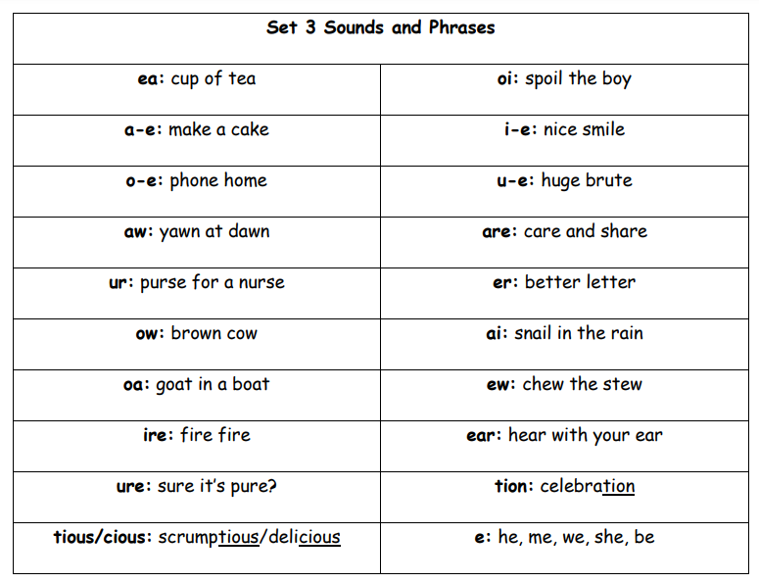

Every speed sound has a list of green words linked to it so your daughter/son can ‘sound out’ and ‘sound blend’ words containing the new speed sound they have just learnt, for example, s-p-oi-l spoil. Your child may have remained in this group. This means they need to consolidate the Set 3 sounds. The progress of all children is tracked carefully and one to one provision will be given to support your child if necessary.
The progression of RWI is as follows:
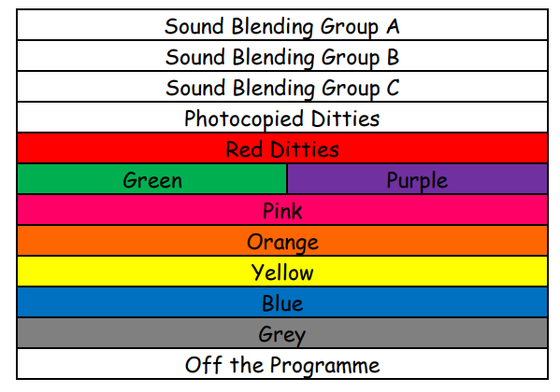
Please do speak to your child’s class teacher if you have any queries or come and chat to me.
Kind regards,
Mrs Webb

