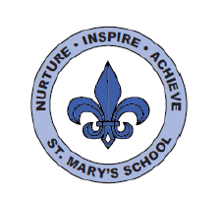
RWI
Dear Parents,
Your child is in ‘Purple Group’
In this Read Write Inc. group children will continue to consolidate their knowledge of Set 1 sounds. They will also be learning new Set 2 sounds (ay, ee, igh, ow, oo, ar, or, air, ir, ou, oy) and be working on ‘Purple books’. These books include fiction and non-fiction titles and will provide an opportunity to practise new sounds. They will also be working on a range of writing tasks related to these books. There are 12 Set 2 ‘speed sounds’ that are made up of two or three letters which represent just one sound, e.g. ay as in play, ee as in tree and igh as in high. These are also known as ‘digraphs’ or ‘trigraphs’. It is important that your son/daughter does not pronounce these as 2 or 3 separate sounds. When your daughter/son sees the ‘speed sound’ letters together in a word, s/he must say just one sound for these letters.
When your daughter/son learns their Set 2 sounds in school they will learn:
- the letters that represent a speed sound e.g. ‘ay’
- a simple picture prompt linked to the ‘speed sound’ and a short phrase to say e.g. ‘may I play’.
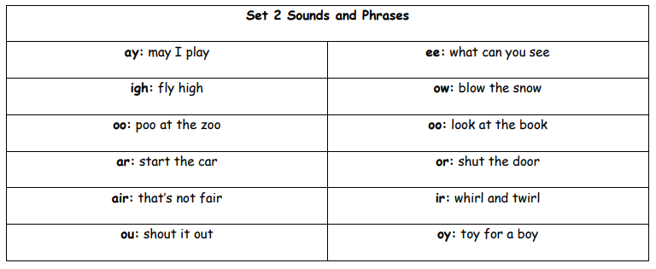
Every speed sound has a list of green words linked to it so your daughter/son can ‘sound out’ and ‘sound blend’ words containing the new speed sound they have just learnt, for example, s-p-r-a-y spray. Your child may have remained in this group. This means they need to continue to practice their Set 1 sound blending skills to ensure they can read real and nonsense CCVC words and CVCC words. The progress of all children is tracked carefully, and one to one provision will be given to support your child if necessary. The progression of RWI is as follows:
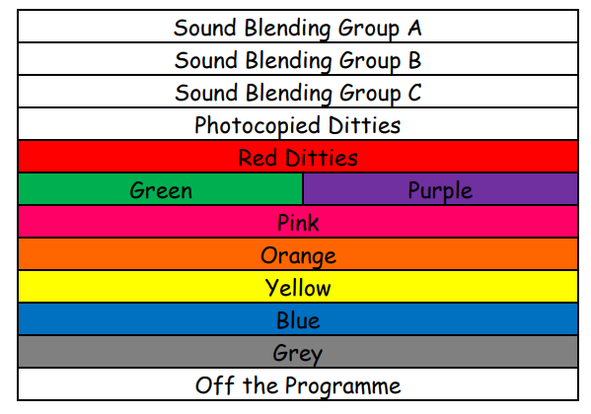
Please do speak to your child’s class teacher if you have any queries or come and chat to me.
Kind regards,
Mrs Webb

