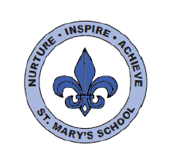
RWI
Dear Parents,
Your child is in ‘Orange group’
In this Read Write Inc. group children will continue to reinforce Set 2 sounds and the letter names. They will also be learning to recognise and read new Set 3 speed sounds. When learning their Set 3 speed sounds they will be taught that there are more ways in which the same sounds are written, e.g. ‘ee’ as in tree and ‘ea’ as in tea. They will be working on ‘Orange books’. These are more complex books including fiction and non-fiction titles which provide an opportunity to practise the new sounds they have learned. They will also be working on a range of writing tasks related to these books.
There are 20 Set 3 ‘speed sounds’ that are made up of two or three letters which represent just one sound, e.g. ‘ea’ as in tea, ‘ow’ as in cow and ‘are’ as in care. These are also known as ‘digraphs’ or ‘trigraphs’. As before, it is important that your daughter/son does not pronounce these as 2 or 3 separate sounds. When your daughter/son sees the ‘speed sound’ letters together in a word, s/he must say just one sound for these letters.
When your daughter/son learns their Set 3 sounds in school they will learn:
- the letters that represent a speed sound e.g. ‘ea’
- a simple picture prompt linked to the ‘speed sound’ and a short phrase to say e.g. ‘cup of tea’.
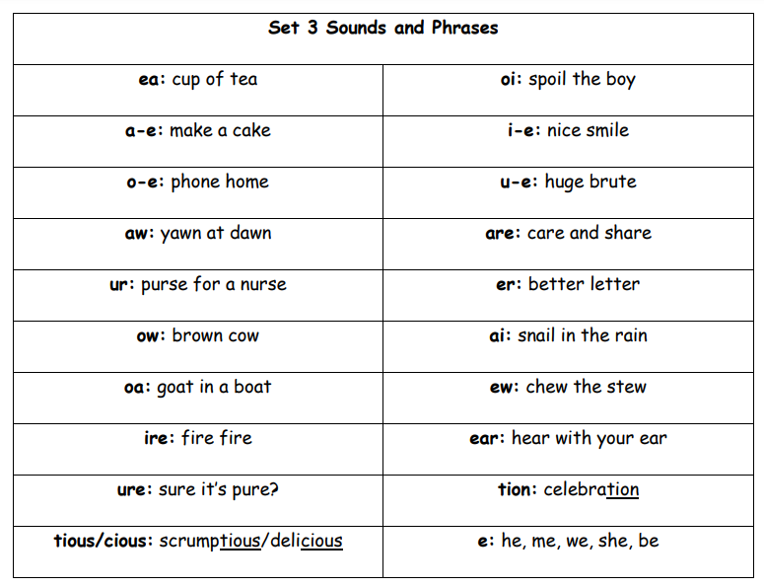

Every speed sound has a list of green words linked to it so your daughter/son can ‘sound out’ and ‘sound blend’ words containing the new speed sound they have just learnt, for example, s-p-oi-l spoil. Your child may have remained in this group. This means they need to consolidate the Set 2 sounds and continue to practice their sound blending skills using these sounds to enable them to read a range of real and nonsense words. The progress of all children is tracked carefully, and one to one provision will be given to support your child if necessary. The progression of RWI is as follows:
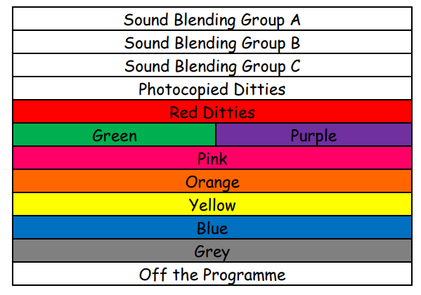
Please do speak to your child’s class teacher if you have any queries or come and chat to me.
Kind regards,
Mrs Webb

