Maths

This term, the children will be revising calculation and problem-solving including working with fractions, ratio, decimals, and percentages.

In algebra, they will be writing and using simple formula and expressions. They will be exploring patterns and describing number sequences. They will also use coordinates and algebra to describe position and movement.

The children will apply their understanding of formulae to find the area of parallelograms and triangles and the volume of cubes and cuboids.

We will solve problems involving angles in a circle and angles in triangles and quadrilaterals.

We will build on our understanding of line graphs. pie charts and the mean to solve problems.

English

This term we will be continuing to develop our love of reading, with a focus on our literary heritage. Our class book this term is the modern classic “Goodnight Mr Tom.” We will also be reading extracts from A Cake for the Gestapo, linked to our topic on the Occupation.

We will be using a range of non-fiction texts and online resources to support our learning in history and science.

We will be writing in a range of styles, including blogs, letters, reports, instructions, and explanations.

Science

This term, we will be learning about the human circulatory system and the impact of diet, exercise, drugs, and lifestyle on our bodies.

The children will explore how blood and nutrients travel through the body: studying blood vessels and blood components.

During this topic we will work on our scientific enquiry skills by planning and carrying out heartrate investigations.

This will link with our work on averages and graphs in maths.

Year 6 Summer Term
Fit For Life
The Occupation

UNCRC
We will be focusing on these articles:
6: You have the right to life and to grow up healthy
12: Your right to say what you think should happen and be listened to.
13: Your right to have information
29: Your right to become the best you can be.
33: Your right to be protected from dangerous drugs.


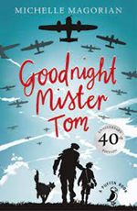
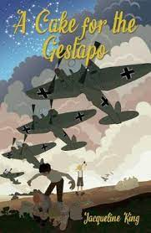
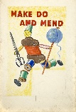
Computing
This term, the children will be continuing to develop their coding skills. They will use computing to explain and present aspects of their learning in other subjects.

As part of our Fit for life topic, we will use excel to develop their understanding of spreadsheets, explore blogs and consider important aspects of staying safe online.

History – The Occupation
This topic will enable the children to develop their skills as historians and will also give them rich opportunities for cross-curricular work in other subjects especially English.

The children will be learning about the changes that happened during this period.

They will explore similarities and differences and will also find out what it was like to be a child at this time.
DT
As part of our ‘Occupation’ topic, we will be focussing on designing and making through a make do and mend project.

Later in the term our focus is food: planning, preparation, and safety in the kitchen.

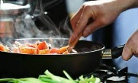

PSHE
We are continuing to use SCARF for our PSHE teaching. This term our units are “Being My Best” and “Growing and Changing.”
We will also explore feelings around transition as we prepare for secondary school.

Art and Design
This term, we will be building on our understanding of the elements of art and further developing our language of art.

We will be developing our drawing and painting skills with a project on the blue and white tiles found in Funchal. We will also be exploring 3D form and the use of textiles linked to our topics.

Geography
This term we will focus our attention on the oceans and the issues that affect them. We will investigate solutions such as the development of no-take zones to protect marine environments.

Music
The children will listen and respond to music linked to our WW2 topic. Later in the term, we will be preparing for our leavers’ assembly.

PE
This term, we are working on gymnastics and athletics. We will also be looking at our fitness levels and will be planning activities to improve our fitness as well as finding ways to measure our progress. After half term, we will be working on a dance for our leaver’s assembly. Towards the end of term, we will be taking part in a range of outdoor activities as part of our Year 6 activity week.

RE
RE is not a major focus this term, but we will explore big questions, comparing different viewpoints and reflecting on our own ideas.

French
We will be consolidating our learning: developing more detailed verbal and written responses and expressing opinions.
Visits and Events
To include:
End of KS2 assessments
War Tunnels – evacuation walk
Secondary transition days
Activity Week
Leavers’ Assembly

