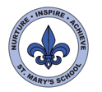
Year 6 Spring Term
Topics:
Diverse Planet – Changing Times, Changing World.

Science
Our first science unit this term is classification.

The children will be learning how micro-organisms, plants and animals are grouped according to specific characteristics.

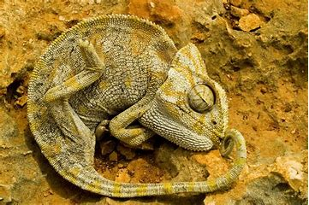

As part of our Diverse Planet topic, we will be investigating how animals and plants are adapted to suit their environments and how this adaptation leads to evolution.

We will explore how fossils give us information about living things from the past.

We will research the work of Charles Darwin, Mary Anning and Alfred Wallace – what did they discover and why was their work important?
Maths

The emphasis in Maths continues to be on children developing a deeper understanding of mathematical concepts and how they are linked. The focus is on asking questions, thinking mathematically and communicating their reasoning.

Our topics this term are:
- Fractions, decimals and percentages
- Ratio and Proportion
- Solving problems using the four operations including the conversion of units
- Area, perimeter and volume
- Algebra – pattern and expressions
- Geometry - angles

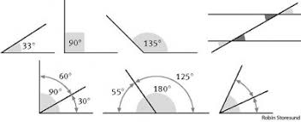
English
This term we will be reading a wide range of texts to broaden our reading experiences, including: The Adventures of Odysseus, What Mr Darwin Saw and The Last Wild - a dystopian adventure with environmental themes. Exploring the plot, characters, structure, and language of these books will give us a great starting point for writing newspaper reports, adventure stories and a wide range of poetry.

Later in the term, we will study Shakespeare’s Macbeth. The children will use drama to explore character’s feelings, thoughts and motives and consider how language is used to build tension and atmosphere. They will explore themes within the text such as: ambition, power and the supernatural.

We will be using a range of non-fiction texts to support our learning in other subjects. We will be writing non-chronological reports, letters, and biographies linked to our topics.

UNCRC
This term we will be focussing on Articles:
12: You have a right to be heard and to say what you think should happen
13: You have the right to find out things and share what you think with others
17: Your right to information
19: Governments should do everything they can to protect each child from harm
29: Children should be encouraged to be themselves, be responsible and be the best they can be.

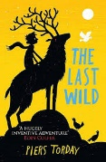

History
History is not a focus this term, but there will be cross-curricular links made through our learning in Science, English and Geography.
DT
We will be exploring mechanical systems and will use these to design and make a moving toy using cams. As part of our Diverse Planet topic, we will also consider the importance of technology in protecting our planet.

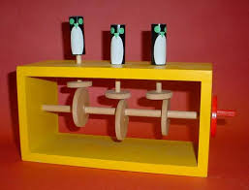
Computing
This term, we will be further developing our research and presentation skills. The children will learn about networks, databases and spreadsheets. They will use coding to explore inputs, outputs and variables. They will create multimedia presentations to explain and present aspects of their learning in other subjects. They will continue to develop their understanding of e-safety so that they are safer online.

Art and Design
This term, we will be looking at how artists and designers have used natural forms to inspire their work. We will be using sketch books to explore, develop and revisit our ideas: exploring printing, painting and experimenting with composition. After half term, we will focus on textiles and use Mardi Gras as the inspiration for costume design.

PSHE
We are now using SCARF as the basis of our PSHE programme. Our topics this term are Keeping Safe and Rights and Respect. We will also continue to have visits from the You Matter team.
Geography

Our topic “Diverse Planet” will draw together and develop children’s knowledge of places around the world as well as key aspects of physical and human geography. They will explore global issues that are impacting our planet such as climate change and pollution.

French
Our main themes this term are: places, where we live, directions around town and parts of the body. Madame Surcouf will continue to teach French this term.

Music
Our focus this term is on composition. We will be exploring different sections of The Carnival of The Animals and will use this as a stimulus for creating our own pieces.


RE
This term, we are undertaking a comparative study. Our theme is religion and the environment, and our key question is how do religions put belief into action?

PE
We are continuing to work through the different learning cogs in our REAL PE programme. This term our focus is on developing our cognitive and creative skills. PE days are on Tuesdays and Thursdays this half term and Mondays and Tuesdays after half term, when we will be working with members of the sports development team on dance and netball.
Visits and Events
Durrell
Holocaust workshop
De Putron competition
You Matter

