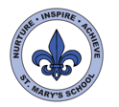
Year Six Autumn Term
Topics:
Our World, Our Rights
Lest We Forget (WW1)

Science

This term our science units are electricity and light.

Year 6 will investigate circuits: giving reasons for the brightness of bulbs or the volume of buzzers. They will use recognised symbols to draw circuit diagrams.

The children will use their understanding of how light travels to investigate shadows and to explain how we see things.

As part of our history topic, we will also investigate some of the developments in science and technology during WW1.

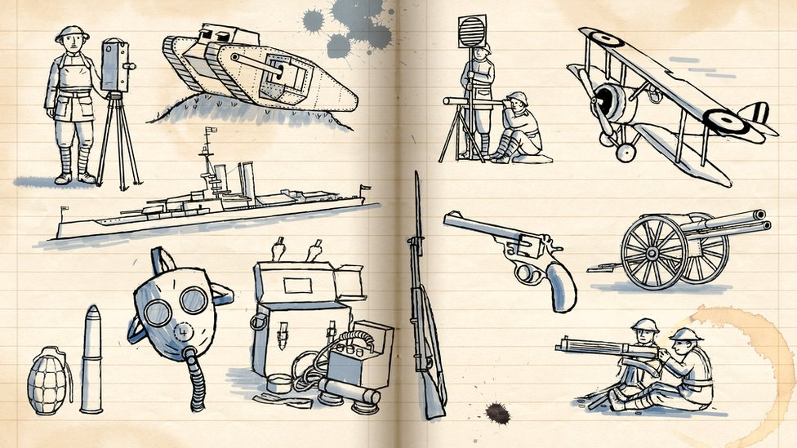
Maths
Throughout Year 6, children will be encouraged to think and communicate mathematically: developing their logic and reasoning skills and sharing their thinking with their peers. Mathematical fluency, including instant recall of times tables, is key.

This term the focus is on number. The children will be developing their understanding of numbers up to 10,000,000. They will be using negative numbers in context and developing their understanding of rounding. They will use the four number operations, including mixed operations and formal written methods, to solve problems.
We will also be calculating with fractions and decimals.

The children will build on their understanding of 2D and 3D shapes including parts of a circle.
English
In Year 6 there is a strong emphasis on reading for pleasure; children will be encouraged to read a wider range of literature and to recommend books to their peers.

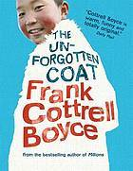

As a class we will be exploring and enjoying a range of texts including: The Unforgotten Coat, The Arrival, The Viewer and War Horse.

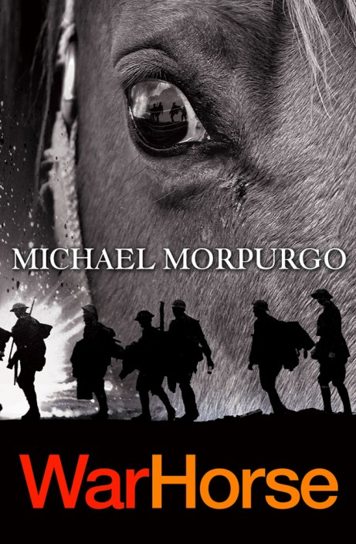

In the second half of term, we will focus on the use of imagery in poetry and historic narrative. We will write poems, diaries and letters linked to our WW1 topic. We will also be learning about persuasive campaigns and balanced arguments.

UNCRC
This term we will be focussing on the following articles:
2: Children won’t be discriminated against.
13: Children have the right to give and get information
16. Your right to privacy
19: You should not be harmed and should be looked after and kept safe.
24. Your right to see a doctor and have healthy food and clean water
28: Your right to learn and to go to school
29: Children should be encouraged to be themselves, be responsible and be the best they can be.
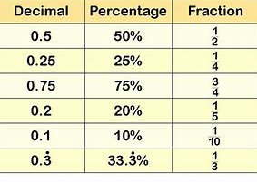

DT
Our design and technology work will focus on structures. We will also make links with our science and history units. We will explore technology in the trenches and make items such as periscopes and Morse code units.

Computing
This half term, the children will be looking at how to be safe, respectful, and responsible online, and how they can report any concerns. They will be using the internet for research and will present their learning in a range of forms.
We will use a range of software to develop our coding skills: writing code to solve different problems and to create a game.
We will also be working on digital imagery and the children will create their own animations.

History – WW1 Life in the Trenches
This topic will enable the children to develop their skills as historians. It will also give them rich opportunities for cross-curricular work in other subjects. The children will be learning about the conditions in the trenches. They will investigate the changes that happened during this period and the impact that this had on human life and warfare.

PSHE
To start the year, the children will develop their class contract using the UNCRC articles. The children will consider what it means to be part of an effective learning community. We will be having regular visits from the YouMatter team. Our units this term are ‘Being Me in My World’ and ‘Celebrating Difference.’

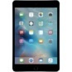

Art and Design
We will begin the term by developing our drawing skills and use of colour, pattern and texture. As part of our work on Remembrance, we will be exploring the theme of poppies. Following our visit to the Map of Wonders, we will continue our next journey with the Story Teller and ArtHouse Jersey.

Geography
We will start the year by using maps and atlases to develop our locational knowledge. We will use The Unforgotten Coat to develop our understanding of different places. We will look at energy and other natural resources. Later in the term, we will investigate different types of settlement and economic activity including fair trade.

R.E.
As Part of our topic on Our World, Our Rights, we will be finding out about different world religions before focussing in more detail on Islam.
As we approach Christmas, we will explore the question: why was Jesus called the Messiah?

French
Madame Surcouf will be teaching French. Themes this term are months, seasons, weather and transport.
P.E.
PE days are a Monday and Friday. We will continue to follow our REAL P.E. programme as well as working with sports coaches. As always, earrings should be removed for P.E. days and hair should be tied back.

In the past Year 6 have been able to do level 2 bikeability. I will let you know if this is on offer this year when I hear back from the team.

Music
Our focus this term is on composition using melodies associated with WW1. We will also be developing our skills on the ukele!
Visits and Events
Map of Wonders exhibition

Jersey Museum – power and protest exhibition

Mosque – Jersey Islamic Centre



