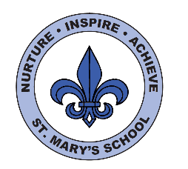
Curriculum Overview
Year Five - Summer

English

We will begin our first half term by reading the book Rosie Revere engineer. We will discuss the language and themes in the book and use the story as a stimulus for writing an alternative narrative ending. We will learn about the Great Exhibition, which took place in the Victorian era, and use well chosen descriptive vocabulary and techniques to create setting and atmosphere.
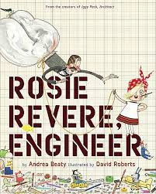

Next half term we will be visiting the States Chamber. Therefore, writing will focus on the purpose to persuade and looking at different techniques we can use to do this. We will practise persuasion through both writing and holding class debates.

For our final learning journey will be based on the book Cinnamon by Neil Gaiman.

Science

In Science this half term we will be investigating the properties of materials. We will be learning about different examples of reversible and irreversible changes.

We will also learn different methods to separate materials for example, sieving and filtering, linked to our Victorian topic and ‘The Great Stink’.
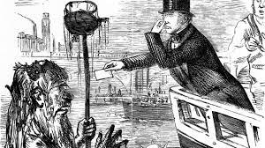

The final science focus is Animals and living things. We will look at different life stages for humans and this will include puberty and a session run by You Matter. There will be more information given to you on this nearer the time.

Maths

We will continue our work on decimals, looking at comparing and rounding decimals as well as adding and subtracting these.

We will then be investigating percentages followed by ‘angles’. We will learn to identify different types of angles, measure and draw angles.
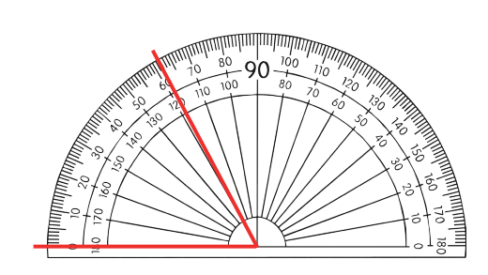

Measuring is another unit we will cover, looking at converting units of measure and solving problems.

In the final half term, we will learn about area and perimeter, focusing on area of composite shapes and estimating.

This is followed by a short unit on volume.

We are always practising our maths fluency, with daily activities to start the day to keep previously taught concepts fresh in pupil’s minds.

UNCRC
This term we will be focussing on Articles:
Article 29 - Your education should help you use and develop your talents and abilities. It should also help you learn to live peacefully, protect the environment and respect other people.

This will link to our science topic next half term as we talk about animals and living things, including humans and we have our residential trip to St Aubin’s Fort.
Article 32 - You have the right to protection from work that harms you, and is bad for your health and education. If you work, you have the right to be safe and paid fairly.
This will link to our History topic, where we will look at how children were treated during this period.

This half term s
PE/Games

Our PE sessions will take place on Mondays and Tuesday this half term, please wear PE kit on these days. If it is warm weather, please have a hat for outside lessons and apply sun cream before coming to school.

.

Important dates
States Chamber: June 19th
Swim safe at the beach: 23rd June
St Aubin’s Fort: 3-5th July
Safety in Action: 18th July
Art/DT

In art this term we will study the work of William Morris and create our own printing in his style. We will have two extended DT sessions, where we will investigate, design, make and evaluate our own cam toy.
Lastly, we will look at Indian influences of art and use a range of medium.
Music

The children will learn songs linked to then Victorian era.

Home Learning

This half term, children will be set a home learning project linked to the Victorians, on an area of the era that they are particularly interested in. This can take any form – poster, video, 3d project, Powerpoint.
This will be due Monday 22nd May.

Next half term they will be practising their debate for the States Chamber.

Spellings will be set every Monday and are to be practised for Friday.
Please practise times tables.
Maths homework will be set on a Monday to be completed by Friday.
Reading each night- diaries to be handed in on Mondays for monitoring
There may be additional activities set to reinforce class learning.

History / Geography

This half term, in history we will be learning about the Victorians. This will iclude a homework project. We will learn about key events, inventions and inventors, the Industrial revolution and what life was like for children from both rich and poor backgrounds. We will complete the topic with a Victorain day.
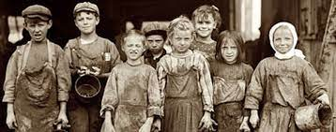
Our Geography focus is coasts and rivers.
Next half term we will be learning about India, which links with our RE topic.
Computing

This half term we will be looking at how a flat-file database can be used to organise data in records. We will use tools within a database to order and answer questions about data, as well as create graphs and charts from our data to help solve problems. We will also use a real-life database to answer a question, and present work to others.
We will continue to use iPads to support learning across the curriculum, as well as reinforce the importance of keeping safe on the internet. Please use the link below for adult guidance: https://www.nspcc.org.uk/keeping-children-safe/online-safety/parental-controls/

https://www.thinkuknow.co.uk/parents/articles/parental-controls/

RE/PSHE

This half term our topic for PSHE is ‘image.
In RE next half term we will learn about the religion of Sikhism. We will look at beliefs and ways of life, as well as the 5K’s and places of worship. We will learn about the Sikh holy book and religious ceremonies. We hope to cook and taste some food Sikhs would eat at the langar.

