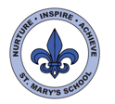
Curriculum Overview
Year Five - Spring Term

English

We will be writing non-chronological reports about our own rainforest creatures, using the short film Pandora as a stimulus. We will focus on using relative clauses, fronted adverbials, ambitious vocabulary and brackets.

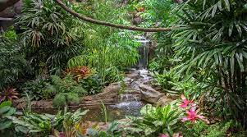

Next half term our class books will focus Crime and Punishment. As a class we will read extracts from, ‘Holes’ and ‘Gangster school’.
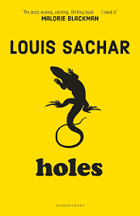

We will use ‘The Highwayman ‘as a stimulus for our creative writing. We will use the format of Read, Write, Perform to write our own football manager speeches.

Science

In Science this half term we will begin our topic ‘Living things and their habitats’. We will discuss the 7 life processes in all living things and compare plants and animals.
We will also look at how plants reproduce in different ways. We will end the topic comparing animals’ life cycles, across different classifications.

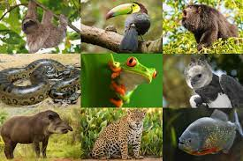

‘Properties of Materials’. We will develop our scientific enquiry by investigating the properties of different materials. We will test for transparency, solubility and conductivity of materials. We will also test the response to magnets. We will be expanding our vocabulary to be able to describe the properties of each material and suggest reasons why certain materials are used for certain objects.

Maths

We will revisit multiples, factors, prime and square numbers. We will also continue to practise using formal written methods for multiplication and division to record our calculations.

We will then be investigating ‘angles’. We will learn to identify different types of angles, measure and draw angles.
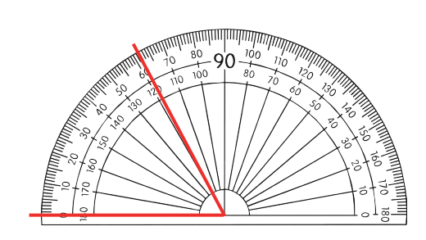

We will then begin our topic on Fractions. We will start by dividing to make fractions. We will then learn to compare and order fractions.

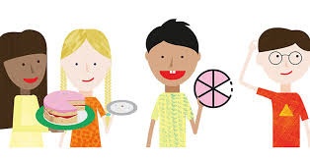

Next half term we will complete our topic on fractions by learning to add, subtract and multiply fractions. We will then move on to decimals and percentages.

UNCRC
This term we will be focussing on Articles:
Article 17 - You have the right to get information that is important to your well-being, from radio, newspaper, books, computers and other sources. Adults should make sure that the information you are getting is not harmful, and help you find and understand the information you need.
This will link to ‘Internet Safety Day’ this half term.
Article 32 - You have the right to protection from work that harms you, and is bad for your health and education. If you work, you have the right to be safe and paid fairly.
This will link to our Geography topic next half term as we will learn about Fairtrade.

This half term s
Home Learning
The homework has been posted on Seesaw. Due 1st February.

Spellings will be set every Monday and are to be practised for Friday, along with Maths homework.
Please practise times tables little and often. Please, please hear your child read 4 times a week. Diaries will be checked in school on a Monday.
Some children cannot tell the time on an analogue clock. Please can you practise this at home by regularly asking what the time this. This is not a year 5 objective and they must be secure in this life skill to enable them to access some of our maths.
Trips
Rainforest workshop- Jersey zoo – Wednesday 18th January.
Orchid Foundation -tbc

Music

The children will compose their own music with a rainforest scheme.
Next half term the children will have the ‘French Experience’ – which means they will have a specialist teacher (Madame Surcouf) teaching French three times a week. These sessions are fun, interactive and very engaging.
Art/DT

In art this term we will create some rainforest-inspired pieces of artwork based on the work of artist Henri Rousseau. We will study his work and use sketching and painting techniques in our own creations.

Linked to Crime and Punishment, we will debate, Is street art a crime? And look at work of famous street artists, before creating our own.
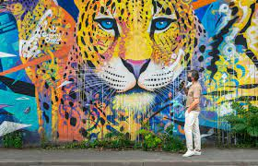

PE/Games

Our PE sessions will take place on Mondays and Fridays this half term, please wear PE kit on these days and bring a coat.

.

Computing

This half term we will be using computing to support our Science lessons. We will use iPads to create stop-animations linked to the rainforest. We will also be using iPads to perform and record our writing in English.
Internet Safety Day is Tuesday 7th February, so children will investigate how to stay safe online and learn what type of information is safe to share and not. Please use the links below for adult guidance:
https://www.nspcc.org.uk/keeping-children-safe/online-safety/parental-controls/

https://www.thinkuknow.co.uk/parents/articles/parental-controls/

RE/PSHE

This half term our topic for PSHE is Keeping safe.
In RE we will look at the Bible and different types of writing in the Holy book. Next half term we will revisit ‘Christianity’ based on the topic ‘Easter’.


History / Geography

This half term, our Geography topic will link with locating rainforests around the world. We will look at weather, climate and layers of the rainforests, as well as animals that live their and use of land and issues these areas face.
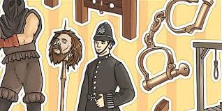
Next half term we will be focus on History- linked to crime and punishment over time. We look at different eras and how punishment was enforced, and compare these to today’s justice system.

