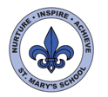
Curriculum Overview
Year Four
Summer Term

English

We will begin the term by writing acrostic poems using the book ‘The Lost Words’.
We will then focus on non-fiction texts and will be writing our own explanation texts to explain the journeys of migratory animals. We will be using the text ‘We Travel So Far’ as our text driver.

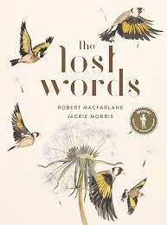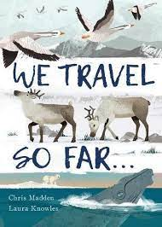

After the half term, we will be learning about the features and structure of playscripts.
We will then focus on descriptive writing linked to our class text ‘Varmints’.

Throughout the summer term we will be reading various texts linked to our topics to develop our reading skills. We will be revisiting Year 4 spelling rules each week and these will be set as homework.

Science

Throughout the Summer term our topic will be ‘Living Things’
We will be looking at different ways to group animals as well as scientific animal classifications. We will be looking at the positive and negative effects of humans on living things and their habitats. We will be discussing the impact on local environments and the global impact.

We will learn about living things in our local environment by bird watching, minibeast hunting and on our trip to the Scout Hut. 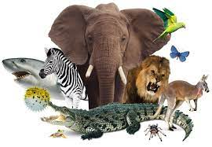
We will then learn about living things from around the world with a particular focus on migratory animals.

We will then be developing our scientific enquiry skills by planning a research question and presenting the findings.

Maths

We will begin the term with our topic on Fractions. We will be finding equivalent fractions, writing mixed number fractions and simplifying fractions. We will also learn how to add and subtract fractions.

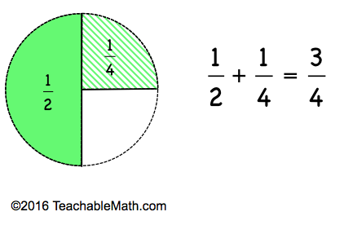

After half term, we will begin our topic on decimals, including money. We will learn how to write tenths and hundredths, compare decimals and how to round decimals. Pupils will then learn how to compare money by identifying significant digits and converting from pounds to pence.

We will also be revisiting place value and the four basic operations (addition, subtraction, multiplication and division).

Homework tasks will be set weekly to help support our learning in class.


UNCRC
This term we will be focussing on Articles:
13 Freedom of expression) Every child must be free to express their thoughts and opinions and to access all kinds of information, as long as it is within the law.
31(leisure, play and culture) Every child has the right to relax, play and take part in a wide range of cultural and artistic activities.

Computing

This term we will be focussing on developing multimedia presentations. Our presentations will link to our science topic and children will have the opportunity to present these to the class.

We will be using IT in a variety of ways across the curriculum too. Including, using google maps as part of our Geography.
PE/Games

Our PE sessions will take place on Mondays and Wednesdays.

On Mondays we will be swimming at LQ sports centre, Children will need to come to school in PE kit with their swimming costumes / shorts underneath. In a bag they will also need a towel, goggles, hat and underwear.

Music
This term the children will receive specialist French horn tuition from Jersey Music service every Wednesday. Please remember your instrument each week.
Art/DT

We will begin the term with a DT project called ‘Moving Monsters’. The children will investigate techniques for making simple pneumatic systems and then design their moving monster using one of these systems. We will then be using a picture book – ‘The Bluest of Blues’ – to inspire our artwork. This will include sketching, cyanotype printing and sketchbook development.
After half term our DT project will focus on food from Spain & Portugal and we will be cooking.
If you have any family recipes you would like to share with us then please do!

Geography

We will start by developing our understanding of ‘maps’ and will use local maps to plan routes and develop our knowledge of compass points and direction.
After half term, our Geography topic is ‘Spain & Portugal’. We will use maps to locate countries in Europe then focus on main cities and landmarks in Spain & Portugal. We would like to invite anyone who has links to Spain & Portugal to share these with the class.
French
This term we will be learning vocabulary linked to ‘animals and pets’ to link with our living things topic.
We will then be making links between English, French, Spanish and Portuguese languages through songs and stories.
Home Learning

Project – Each half term the children will be given a topic-related project to complete at home.
Spellings – Spellings will be added to Seesaw each week with some suggestions of different activities to revise them.
Maths – A short task will be set on Seesaw each week. It would also be useful to revise times tables frequently.
Reading – Please read daily!

All homework will be uploaded onto Seesaw.

RE/PSHE

In PSHE we will be discussing ‘Being My Best’ which will cover how we are all unique. We will then be covering ‘Growing and Changing’.
Our RE this term will focus on Buddhism. We will learn about Buddhist teachings, customs and festivals and how we can apply these to our own lives.

