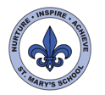
Curriculum Overview
Year Four
Spring Term

English

This term we will be focussing on narrative writing using the text ‘Arthur and The Golden Rope’. This is a picture book which explores a Norse Myth.
Firstly, we will explore the text and learn about the main character Arthur. The children will then write their own adventure narrative using a picture of his journey to support them. We will then move onto creating a character description based on the mythological beast Fenrir, who appears in the book.

After half term, we will be focussing on poetry, using a book called ‘It Starts With a Seed’. The children will perform poetry to their class, and then write their own quatrain. Our final text in this term, will be ‘Greenling’. Using this text, the children will produce their own class text, including newspaper articles they have written
We will continue to develop our handwriting, spelling, punctuation and grammar each week.

Science

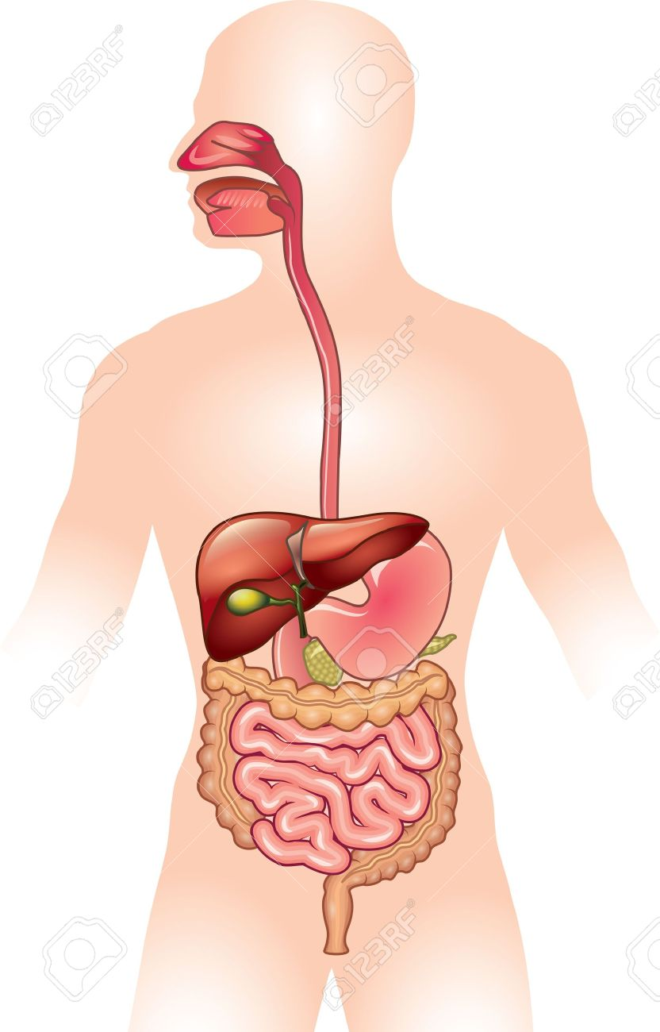

Our first topic is ‘Animals (including humans)’ where we will learn the different types of teeth and what they are used for. They will also learn about where their food goes when they eat and how the body digests it.



In the second half of the term, our science focusses on electricity. We will be learning about where electricity comes from and starting to make simple circuits. Children will learn how to draw circuit diagrams using the correct symbols and problem solve when circuits don’t work.

Maths

Throughout Year 4 we will be developing the children’s fluency and confidence with number. We will be encouraging them to think mathematically: developing their logic and reasoning skills through problems and investigations.

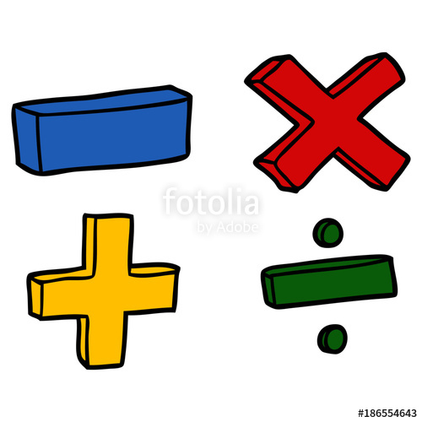

We will begin with a focus on multiplication and division. This will be helping children to develop their written methods and problem solving. We will then move onto graphs work, which will cover reading and drawing picture, bar and line graphs.
Our next topic will then be fractions where we will look at finding equivalent fractions, adding and subtracting fractions and using this knowledge to solve word problems.
After half term we will finish our fractions topic and move onto time, learning to tell the time on the 24-hour clock, converting units of time into hours / minutes / seconds and solving word problems involving time.


UNCRC
This term we will be focussing on Articles:
6. Your right to life and to be healthy.
24. You have the right to the best health care possible, safe water to drink, nutritious food, a clean and safe environment, and information to help you stay well.

History

This term, the children will be learning about the history of Jersey. The unit is delivered by Mr Le Maistre, who works with Jerriais team at CYPES. The children will learn all about how Jersey became an island, Norman culture and some famous legends. During this unit, we will be going on two trips, one to Mont Orgueil castle and one to a beach where children will do some Jerriais rock pooling.
Along the way, the children will also be learning lots of Jerriais!
Art/DT

For the first half term we will be focussing on still life. We will be looking at the work of Paul Cezanne and creating our own still life drawings.
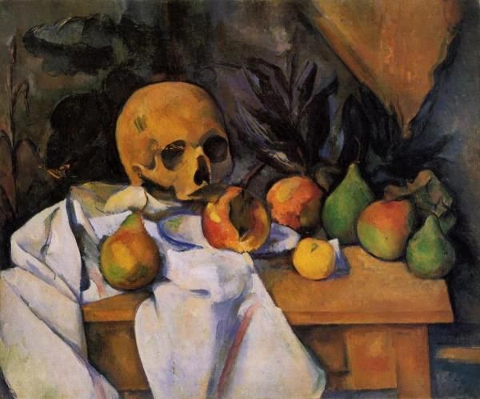
In the second half of the term, our focus will move onto DT. This will link in with our science topic of electricity.
Jerriais

Children will not be learning French this term, as they will be focussing on Jerriais with Mr Le Maistre

PE/Games
Our PE sessions will take place on Wednesdays and Thursdays. On Wednesday, children will be working on their gym skills. On Thursday, children will begin on a core PE unit which focuses on coordination, counter- balances and creating our own games. Please ensure that children have appropriate PE kit, and that all children who have earrings, either bring tape to cover them, or remove them before school on those days.

Computing


In the first half of the term, we will be focussing multimedia presentations. Our multimedia presentations will link to our topic and children will have the opportunity to present these to the class.
In the second half, we will be looking at Internet safety
Music
Miss Stevenard will be teaching music this term. Children will be singing and learning to play percussion instruments
Home Learning

Spellings – 6 words will be given out weekly and tested through dictation on a Friday morning.
Maths and English – A short task to be set on Seesaw each week.
Reading – Please read daily.

All homework will be uploaded onto Seesaw by the following Monday.

RE/PSHE
Our RE this term will feature two short units. One will be all about prayer and the other a unit on Easter. This term in PSHE will be focussing our activities and discussion around rights and respect and a topic called ‘Being Myself’


