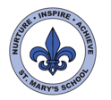
Curriculum Overview
Year Four
Autumn Term
English

This term we will be focussing on narrative writing. Both our reading and our writing activities will be based around two class novels that link with our Topic. For the first half term we will be using Secrets of a Sun King by Emma Carroll and after half term we will be reading Kensuke’s Kingdom by Michael Morpurgo. Within our topic we will also have opportunities to write reports and read and research non-fiction.
Towards the end of the second term we will also be looking at the first of our poetry topics this year.
Throughout the year we will have a big focus on spelling and handwriting.
Children will be selecting books at school to read, and they may also be bringing these home. Some children will also be bringing home a ‘banded’ book.
Please do continue to support your children’s reading at home by hearing them read and sharing books, magazines, audiobooks, newspapers and appropriate websites each day.

Science



Our first topic is focussed on sound. The class will be learning about how sound is made. We will also explore how to adjust the volume and pitch of sounds. Throughout this work, we will be developing the skills of being scientists: devising investigations; making predictions; collecting results and drawing conclusions.

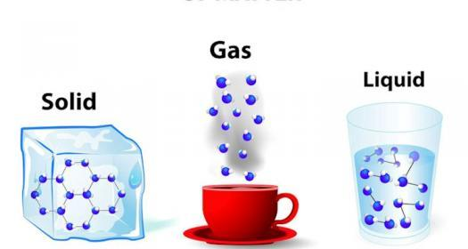

In the second half of the term, our science focusses on the three states of matter: solid, liquid and gas. We will explore materials and their properties and link this to the water cycle.

Maths

Throughout Year 4 we will be developing the children’s fluency and confidence with number. We will be encouraging them to think mathematically: developing their logic and reasoning skills through problems and investigations.

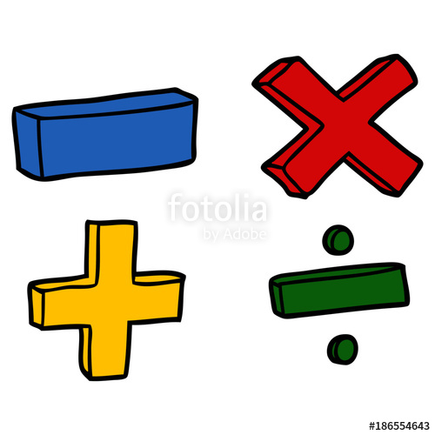

We will begin by developing place value of numbers up 10,000. This will include counting in multiples of 25, 100 and 1000 and comparing numbers using language such as greater than and smaller than.
Children will be rounding numbers and identifying number patterns. We will then move onto addition and subtraction with numbers up to 10,000. This will include the mental methods and the column method. During this unit, children will be exploring problems, deciding which strategy is best to us.


UNCRC
This term we will be focussing on Articles:
6: Your right to life and to be healthy.
13. You have the right to find out things and share what you think with others, by talking, drawing, writing or in any other way unless it harms or offends other people.
29: Your right to become the best you can be.

Computing

Our computing this term will focus on sound. Children will create their own podcasts, which will hopefully be shared on Seesaw. They will write the scripts needed, record the sounds then edit the files.


PE/Games
Our PE sessions will take place on Thursdays and Fridays. The children will have a Tag Rugby coach for the first three weeks of term and will then be doing gymnastics with a focus on balance. On Thursdays, children will be developing core PE skills. Please ensure your children come with the correct PE kits, and any studs need to be removed, or tape brought to school.

History

This term we will be learning about Ancient Egypt. This will include ordering key events on a timeline, looking at the mummification process, studying artefacts and carrying out research, learning about Tutankhamun, the role of Egyptian Gods, and life along the River Nile. We will also have a go at drawing Hieroglyphics.
To celebrate our learning we will also be holding an Egyptian Day where we will invite the children to come to school in fancy dress and carry out various Egyptian related activities throughout the day. This will take place on Thursday 13th October

Home Learning

Project – Each half term the children will be given a topic related project to complete at home.
Spellings – This year we will be working through the Read, Write Inc spelling scheme which teaches the spelling rules. Each week we will publish a list of 10 words that match the rule we are working on. The rule and words will be integrated into our daily tasks and assessed during a dictation exercise on Fridays.
Maths and English – A short task to be set and submitted via Seesaw each week.
Reading – Please read daily.

All homework will be set on Seesaw on a Monday

PSHE

This term in PSHE will be focussing our activities and discussion around ‘Me Being Me in My World’ and ‘Celebrating Differences’.

Music
For the first half term, Mrs Stevenard will be coming into class each week to teach music. She will children develop their listening skills, identifying rhythms and sounds and some singing activities.
French
Children will be continuing with their French, learning new vocabulary and conversational language.

DT

As part of our Ancient Egyptians topic, the children will be developing their design and technology skills to create a hand-operated device which was used in the Egyptian times to transport water. They will explore ways of joining materials, and then design and make their own product in teams.

Visits/Visitors

Visit the Jersey Water board.

