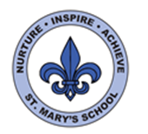
Curriculum Overview
Year Three
Summer Term

Science
Our topic this half term is Flowering Plants. We will be exploring the life cycle and parts of flowering plants, pollination and the role of bees.
After half term we will be learning about Animals and humans, including nutrition, muscles and skeletons!
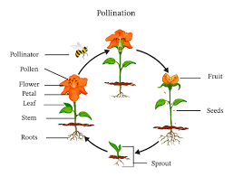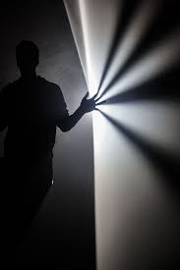

English
This half term we will be focusing on Playscripts. We will be basing our topic around Fantastic Mr Fox, (playscript version) by Roald Dahl.

In the second half of term we will be reading a collection of poems by Michael Rosen, and using these as inspiration for themes to write our own poems.

Please continue to listen to your child read each evening and help them to learn their weekly spellings.

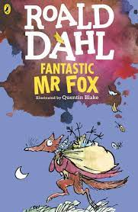

Maths
This half term we will begin our topic on fractions, including adding and subtracting, ordering and drawing fractions as parts of a whole.

We will move onto learning how to draw and measure different types of angles.

We will be exploring and making 2d and 3d shapes, plus finding perpendicular, parallel, horizontal and vertical lines. Our final topic will be measuring and calculating perimeters of shapes.

Please continue to practice quick recall of times tables and number bonds at home with your child.

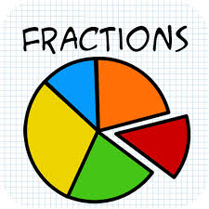

PSHE
This term our Jigsaw topic is called ‘Relationships’.
We will learn about roles and responsibilities in our families. How to be a good friend.

After half term we will move onto the topic ‘Changing Me’.
We discuss how our bodies change from baby to adult.


Geography/History

Our topic this term will be Jersey.
We will explore locations on maps, focus on land use and Genuine Jersey produce. We will also learn about Jersey’s farming history.

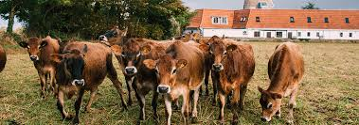
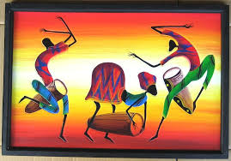
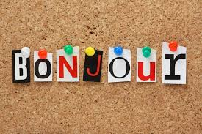
Visits
We are hoping to have a visit to a Dairy Farm after half term.
French
We will be recapping our learning of greetings, instructions, numbers, colours and animals. We will move onto learning food and days of the week.

PE/Games
This term we will have Tennis sessions with a coach on Mondays.
We will also continue with our RealPE program.

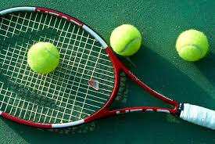
Art
We will be using our sketch books for a still life study of flowers. We will explore the work of artists, such as Ian Rolls, Nick Romeril and Yvonne Coomber, to learn techniques using different mediums. We will also continue with our super ‘Map of Wonders’ projects.

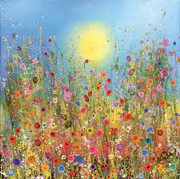

DT/Food tech
Later on in the term, we will be cooking with genuine Jersey products and making some delicious snacks, plus learning about hygiene and safety when preparing food.

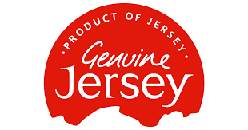
Computing
This term the children will be developing their word processing skills and creating Powerpoint presentations. We will practise typing, editing and lay-out on text on a page, inserting images and saving work.



RE
This term we will be focusing on Hinduism. We will explore the worship, beliefs and practises of this religion. We will learn about important festivals and how the faith contributes to wider society.



