English
Our English will be based on the book, The Tin Forest’. We will be developing our descriptive story writing skills and using paragraphs, plus creating our own instructions and then making a scrap-yard magnetic crane. We will continue to develop our use of dictionaries and thesauruses.

We will move onto ‘The Promise’, by Nicola Davies. After half term we will also be writing persuasive leaflets and letters, linking this to our Geography topic ‘Islands’.

Please continue to hear your child read regularly at home and help them to practise their spellings.

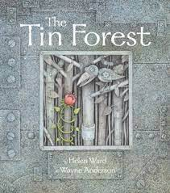

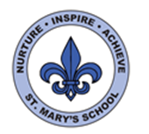 Curriculum Overview Year Three Spring Term

Science
Our topic this half term is Magnets and Forces. We will be learning to be scientists and learning about pushes & pulls as forces. We will explore how things move on different surfaces and explore magnets. We will test the forces of magnetic poles and find out about attraction & repulsion. We will discover which materials are magnetic.

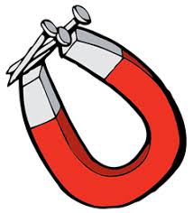

After half term our topic will be Light and Shadow. Children will investigate shadows and how they are formed when a solid object blocks light. We will explore prisms and how rainbows are made!

Maths
This term we will continue to develop multiplication and division methods and skills, by using formal and mental methods and solving word problems. In Year 3 we use numbers up to 1000.

The children should be practising their 2, 3, 4, 5, 8 and 10 times tables regularly. They will also benefit from counting in 10s, 20s, 50s and 100s, forwards and backwards to 1000.

We will move onto solving problems involving measures. This will include Length in cm, metres and km, Mass in grams and kgs, and Volume in millilitres and litres.

We are building reasoning skills by encouraging the children to explain what they have learnt and how they can solve a problem, verbally and by

writing their methods in their Maths journals.


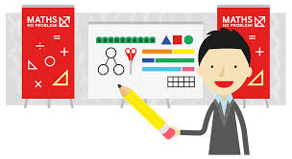
PSHE
This term our topic is called ‘Keeping Safe’.
We will learn about the keeping ourselves safe from harm, such as road safety, internet safety and medicines.

After half term we will move onto the topic ‘Rights and respect’.


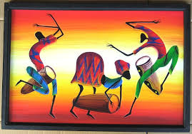
Computing
This term the children will be continuing to use the Scratch program for coding, plus be creating Stop Motion Animations. They will also continue to develop their word processing and typing skills using Word.



Art
We will be using our sketch books for a Tine Forest study. The children will learn sketching techniques, using light and shade through different lines and textures. They will also explore the machine sketches of Leonardo Di Vinci.

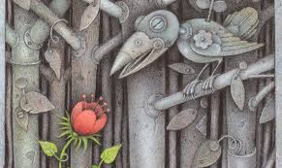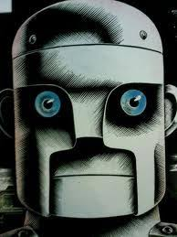

DT
We will be developing our knowledge of pulleys and levers, by designing and making a scrapyard magnetic crane to lift a metal object. They will select their materials and tools to use. They will also test each other’s pulleys and give feedback to each other.

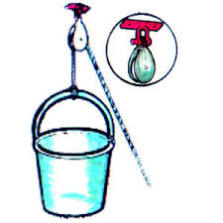
RE
This term we will focus on Christianity and will be learning about Jesus and Miracles, before moving onto the meaning of Lent and Easter.

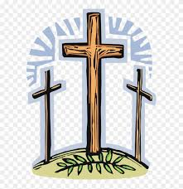
PE
This term we will begin to develop our gym skills. We will also practise balancing, jumping/landing and ball skills. P.E is on Mondays and Wednesdays.

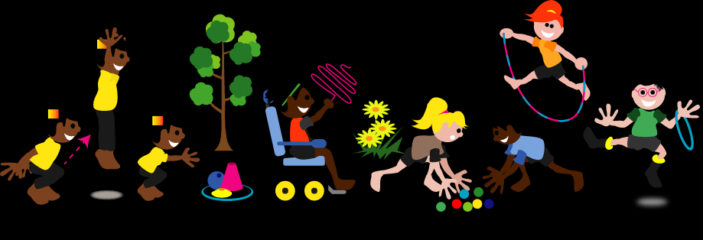
Geography
In the 2nd half of term our topic will be ‘Islands’. During this topic we will compare Jersey to The Shetland Islands. We will learn how to read maps using co-ordinates and compare physical and human features of the islands.

Music
The children will have music sessions with Miss Stievenard this term. They will be learning songs and performing with a variety of instruments.

