Science/Geography
Our topics this term will be Rocks and soils, followed by Volcanoes and Earthquakes.

We will be using scientific terminology to explain the different components of a volcano, how they are formed and why eruptions occur. We will research our own chosen volcanoes from around the world.

In Science, we will spend time examining and classifying different rock and soil types. We will devise our own experiments based on different characteristics of rocks and soils. We will also be exploring how fossils are made.

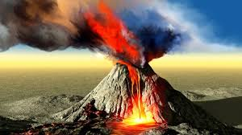
Maths
This term we will be focusing on understanding and confidence with numbers to 1000. We will be exploring the place value of each digit and number patterns within larger numbers, up to 4 digits.

We will be developing addition, subtraction, multiplication and division concepts and methods, using larger numbers.

In Year 3 we recap the 2, 5 and 10 times tables, but children will also be learning their 3s, 4s and 8s. They will also need to practice counting in 50s and 100s.

We build reasoning skills by encouraging the children to explain in detail, how they have tackled and solved a problem.
English

We will be reading and writing stories based on our ‘Stone Age’ Topic. We will be developing our skills through predicting, using lots of descriptive vocabulary and
looking closely at different sentence structures.

Throughout the term we will also develop our non-fiction writing skills, linked to our topics, by writing information leaflets, instructions, menus, and Science reports!

We will be developing children’s reading comprehension skills by studying texts in greater depths and answering a range of questions. Children will also bring home spellings to learn each week.

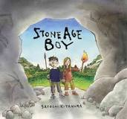
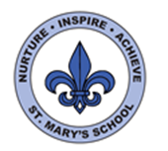
Curriculum Overview
Year Three
Autumn Term

PSHE
This term our Jigsaw topic is called ‘Being me in my world’.
We will identify positive characteristics in ourselves and others. We will explore good choices and actions, and how this affects our world. This will link closely with learning about our rights.



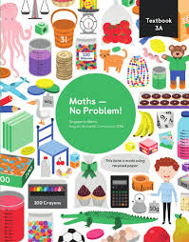

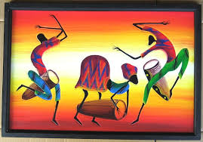
Music
The children will listen and respond to a variety of music. They will be learning songs and performing with percussion instruments and xylophones.

Art
We will be observing Stone age art and using our sketch books to develop our own ideas in this style. We will also sculpt and mould clay to make a round house.

French
This term we will begin to learn how to say basic greetings and simple instructions/questions in French.


Computing
This term the children will be focusing on word processing skills, such as aligning text, changing fonts, correct spacing and using text boxes. They will also be learning how to code using the ‘Scratch’ program.



RE
After half term we will focus on the Nativity story and Christingle. We will explore the meaning of Christmas for Christians.

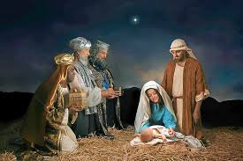
PE
We will have P.E sessions on Mondays and Wednesdays. We will be following our ‘Real PE’ scheme for coordination and ball skills. We will also be learning dance skills.


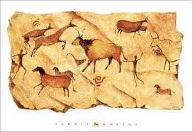
DT
We will be building our own replica dolmens (not to scale!!) but in true Stone age style, they must design a way to move the ‘stone blocks’ without lifting them. They will test and evaluate their technology in groups.

History
This half term we will be studying the Stone age. We will ask historical questions and research our answers using relevant sources. We will also be exploring evidence of the Stone and Ice age in Jersey, including visiting local dolmens. We will look at humans, tools, animals, food and houses during the prehistoric time.



