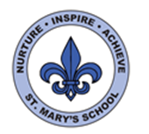
Curriculum Overview
Year Two
Summer Term 2023

English

We will begin the term by finishing our work on Robot Rumpus and will be creating persuasive toy adverts! We will then be writing out own raps, using the text ‘Kitchen Disco’ as inspiration. ‘The Big Book of Bugs’ will be our non-fiction text driver this term and we will be creating our very own fact files.

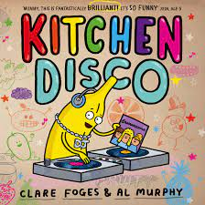

In Read Write Inc this term some of the class will be continuing with the Read Write Inc programme and will continue to learn different sounds and develop their reading comprehension and writing skills. The rest of the class will continue to read a wider range of texts and will be continuing to develop their phonetic awareness, reading comprehension and writing skills.

Science

We will be learning about animals and their habitats. We will be exploring a range of local habitats and exploring living things. We will also think about other places in the world and how habitats might be different. Towards the end of the topic we will also investigate what a good habitat needs to provide for the creatures and wildlife living there.

We will hopefully be going on a range of trips to support our learning such as the Zoo, rock pooling, nature walks and St Catherine’s Woods.

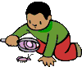

Maths

In Maths this term we will be learning about money, fractions, shape, time and word problems,.

Whilst exploring word problems we will also recap the key elements of addition, subtraction, multiplication and division. In addition, we will review our knowledge and understanding of place value.

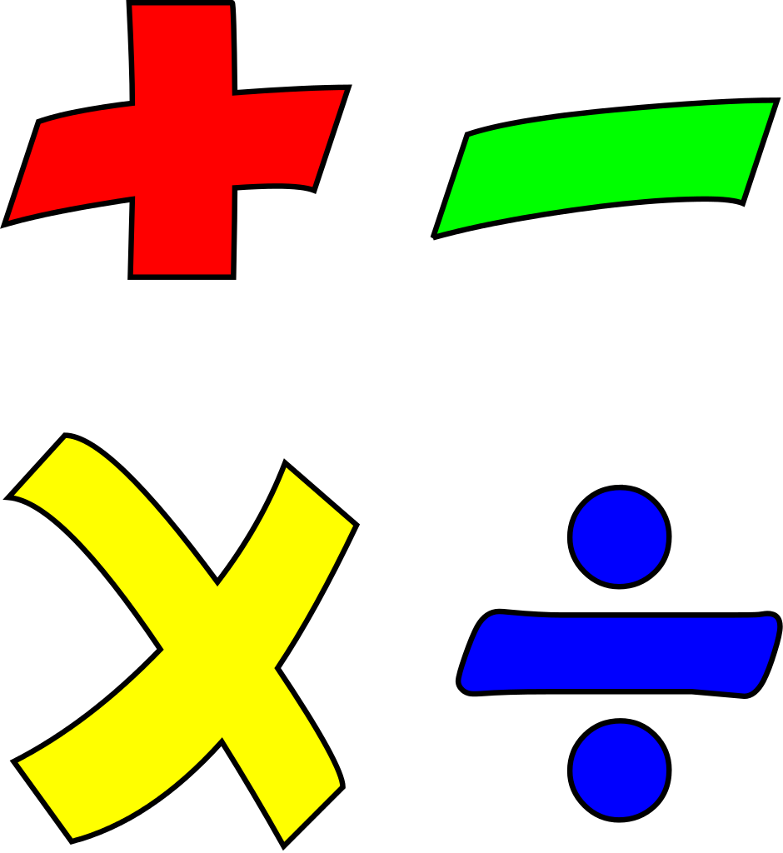

Our work on money and time will continue to deepen our knowledge of measures. Within shape we will focus on 2D and 3D shape.

In fractions we will continue to develop our knowledge and understanding surrounding numerators and denominators and we will also be comparing different fractions.


UNCRC
This term we will be focussing on the following Articles:
Article 19 - You have the right to be safe and to be protected from harm.
Article 12 - You have the right to give your opinion, and for adults to listen and take it seriously.
Article 2 - All children have these rights, no matter who they are, where they live, what their parents do, what language they speak, what their religion is, whether they are a boy or girl, what their culture is, whether they have a disability, whether they are rich or poor.

Art and D.T

In DT we will be focusing on sewing and making our own hand puppets. In Art we will be continuing with the ‘Map of Wonders’ project and will be completing projects linked to Mardi Gras and The Funchal Flower Festival.

PE/Games

In P.E this half term the children will be practising a range of skills including rolling, throwing and catching. We will also be playing a range of team games.

We will also be working on our balancing skills in gym and different movements through dance.
R.E

In RE this term we will be finding out about Judaism, what people who follow that faith believe and what they do. We will find out about their places of worship and their special books and ceremonies they have. We will compare these with ceremonies and books from other religions that we might already know about (e.g. the bible, baptism, marriage, etc.)
Music

The children will listen and respond to a variety of styles of music. They will practise playing a range of instruments to a steady beat.

Geography

We will be focusing on Jersey and the local environment in relation to our science topic. We will also be completing practical fieldwork in our local area and look at how humans have impacted the land.
Computing

This term in computing we will be focusing on Digital Media and Web searching skills and knowing that not everything online is true.

History

Our History focus will be local history. We will be learning about a range of local places and be thinking about how they contribute to our island’s unique history.

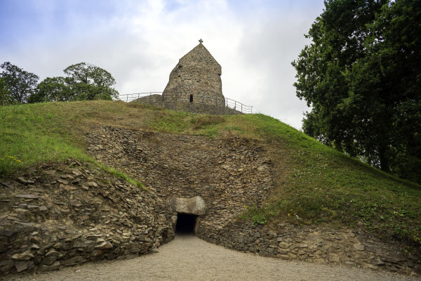

PSHE

In PSHE this half term our topic is ‘Being My Best.’ We will begin by focusing on believing in ourselves and boosting confidence before also exploring a range of themes such as safety, hygiene, and first aid. We will also focus on the ‘The Learning Line’ and explore what learning new things can feel like.


