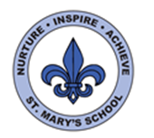
Curriculum Overview
Year Two
Spring Term

English

This half term we will be focusing on ‘The Clockwork Dragon’ and ‘Beegu’. We will read both stories and as well as diving deeply into the stories we will also pick out some key writing skills and practise those. We will be producing a newspaper article and a diary as our outcomes.

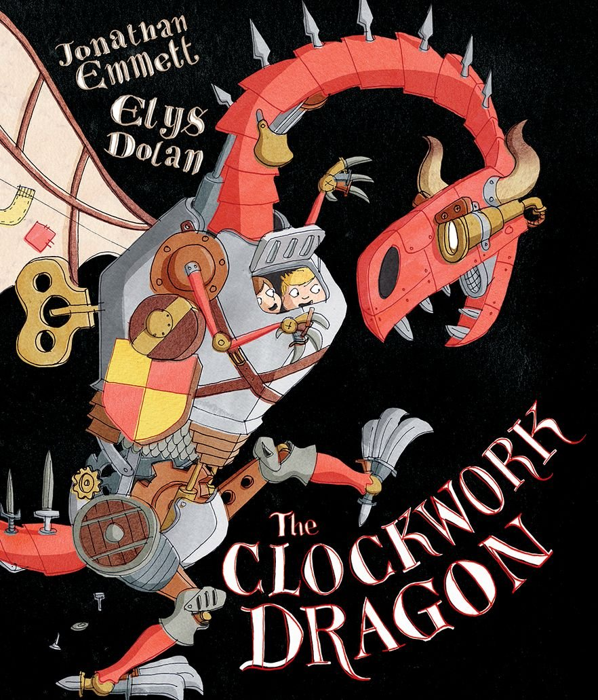

In Read Write Inc the class will be continuing with the Read Write Inc programme and will continue to learn different sounds and develop their reading comprehension and writing skills. Some of the class who have completed RWInc will be continuing to read a wider range of texts and will be continuing to develop their phonetic awareness, reading comprehension and writing skills.

Science

In Science we will be exploring different materials. We will be exploring the different properties of materials and making comparisons. We will also be thinking about the different uses of materials and their suitability for different purposes.

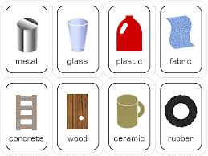

We will be carrying out a range of investigations to test different materials, culminating in a series of challenges to evaluate and use materials for a specific purpose.

Maths

In Maths this half term we will begin by learning all about division. We will start by looking at grouping and sharing and then we will use our multiplication knowledge to help us divide by 2, 5 and 10.

The rest of the term will be focusing on units of measure. We will begin by focusing on length and using metres and centimetres.

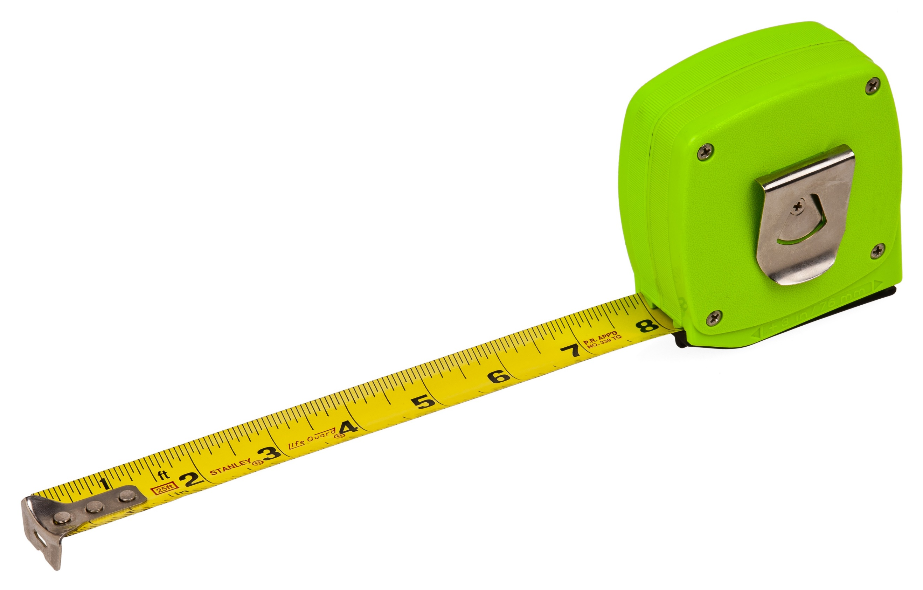

We will also be exploring mass and comparing weight in grams and kilograms.

Later on in the term we will be learning about temperature and learning how to estimate and read temperature.


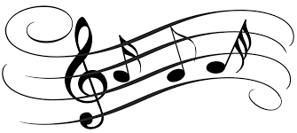
UNCRC
This term we will be focussing on the following Articles:
3: All adults should do what is best for you.
13: Your right to find out things and share what you think with others by talking, drawing or writing.
29: Your right to become the best you can be.
31: Your right to relax and play.
R.E

In RE this half term we will be exploring God and our big question will be ‘What is God like?’ Next half term we will be learning about the Easter Story. We will think about what we can learn from bible stories and why Easter is important to Christians.
Music

Next half term the children will be continuing their music learning with Miss Stievenard.

PE/Games

In P.E this term we will be continuing with our new PE scheme. We will be focusing in particularly on dynamic and static balances. We will also be using a range of well know games, such as rock, paper, scissors and adapting them to incorporate whole body movements.

Geography

This half term we will not be covering any Geography but last term we learnt about the geography of Jersey and started exploring world maps. We will continue this in the Summer Term.
PSHE

In PSHE this term we will be learning about Keeping Safe. The children will learn about keeping themselves safe and how to also keep those around them safe. We cover a range of topics such as medicines and safe and unsafe secrets.

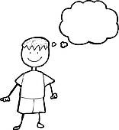

After half term we will be learning about ‘Rights and Respect’ where we will focus on our rights but also respecting each other and how our actions are important.

Computing

This half term in computing we will learning all about programming. We will be learning how to programme and will focus on creating our own algorithms and how to debug an algorithm.

Art and D.T

This half term in D.T we will be making our own moving toys. In particular we will be focusing on using levers and different mechanisms.

In art we will be continuing with the ‘Map of Wonders’ project. We will be learning about the festival of ‘Koleda’ and making hanging decorations.

History

This half term we will be learning about changes in recent history. We will be focusing on how toys have changed throughout time and also explore differences in houses and home life.



