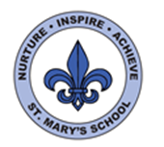

Curriculum Overview
Year Two
Autumn Term

English

During this term we will be focusing on ‘The Snail and the Whale’ by Julia Donaldson. We will be learning how to retell stories and spot patterns within a text. We will also be looking at sentence and story structure and writing our own stories. Throughout the term we will also be focusing on using accurate punctuation.

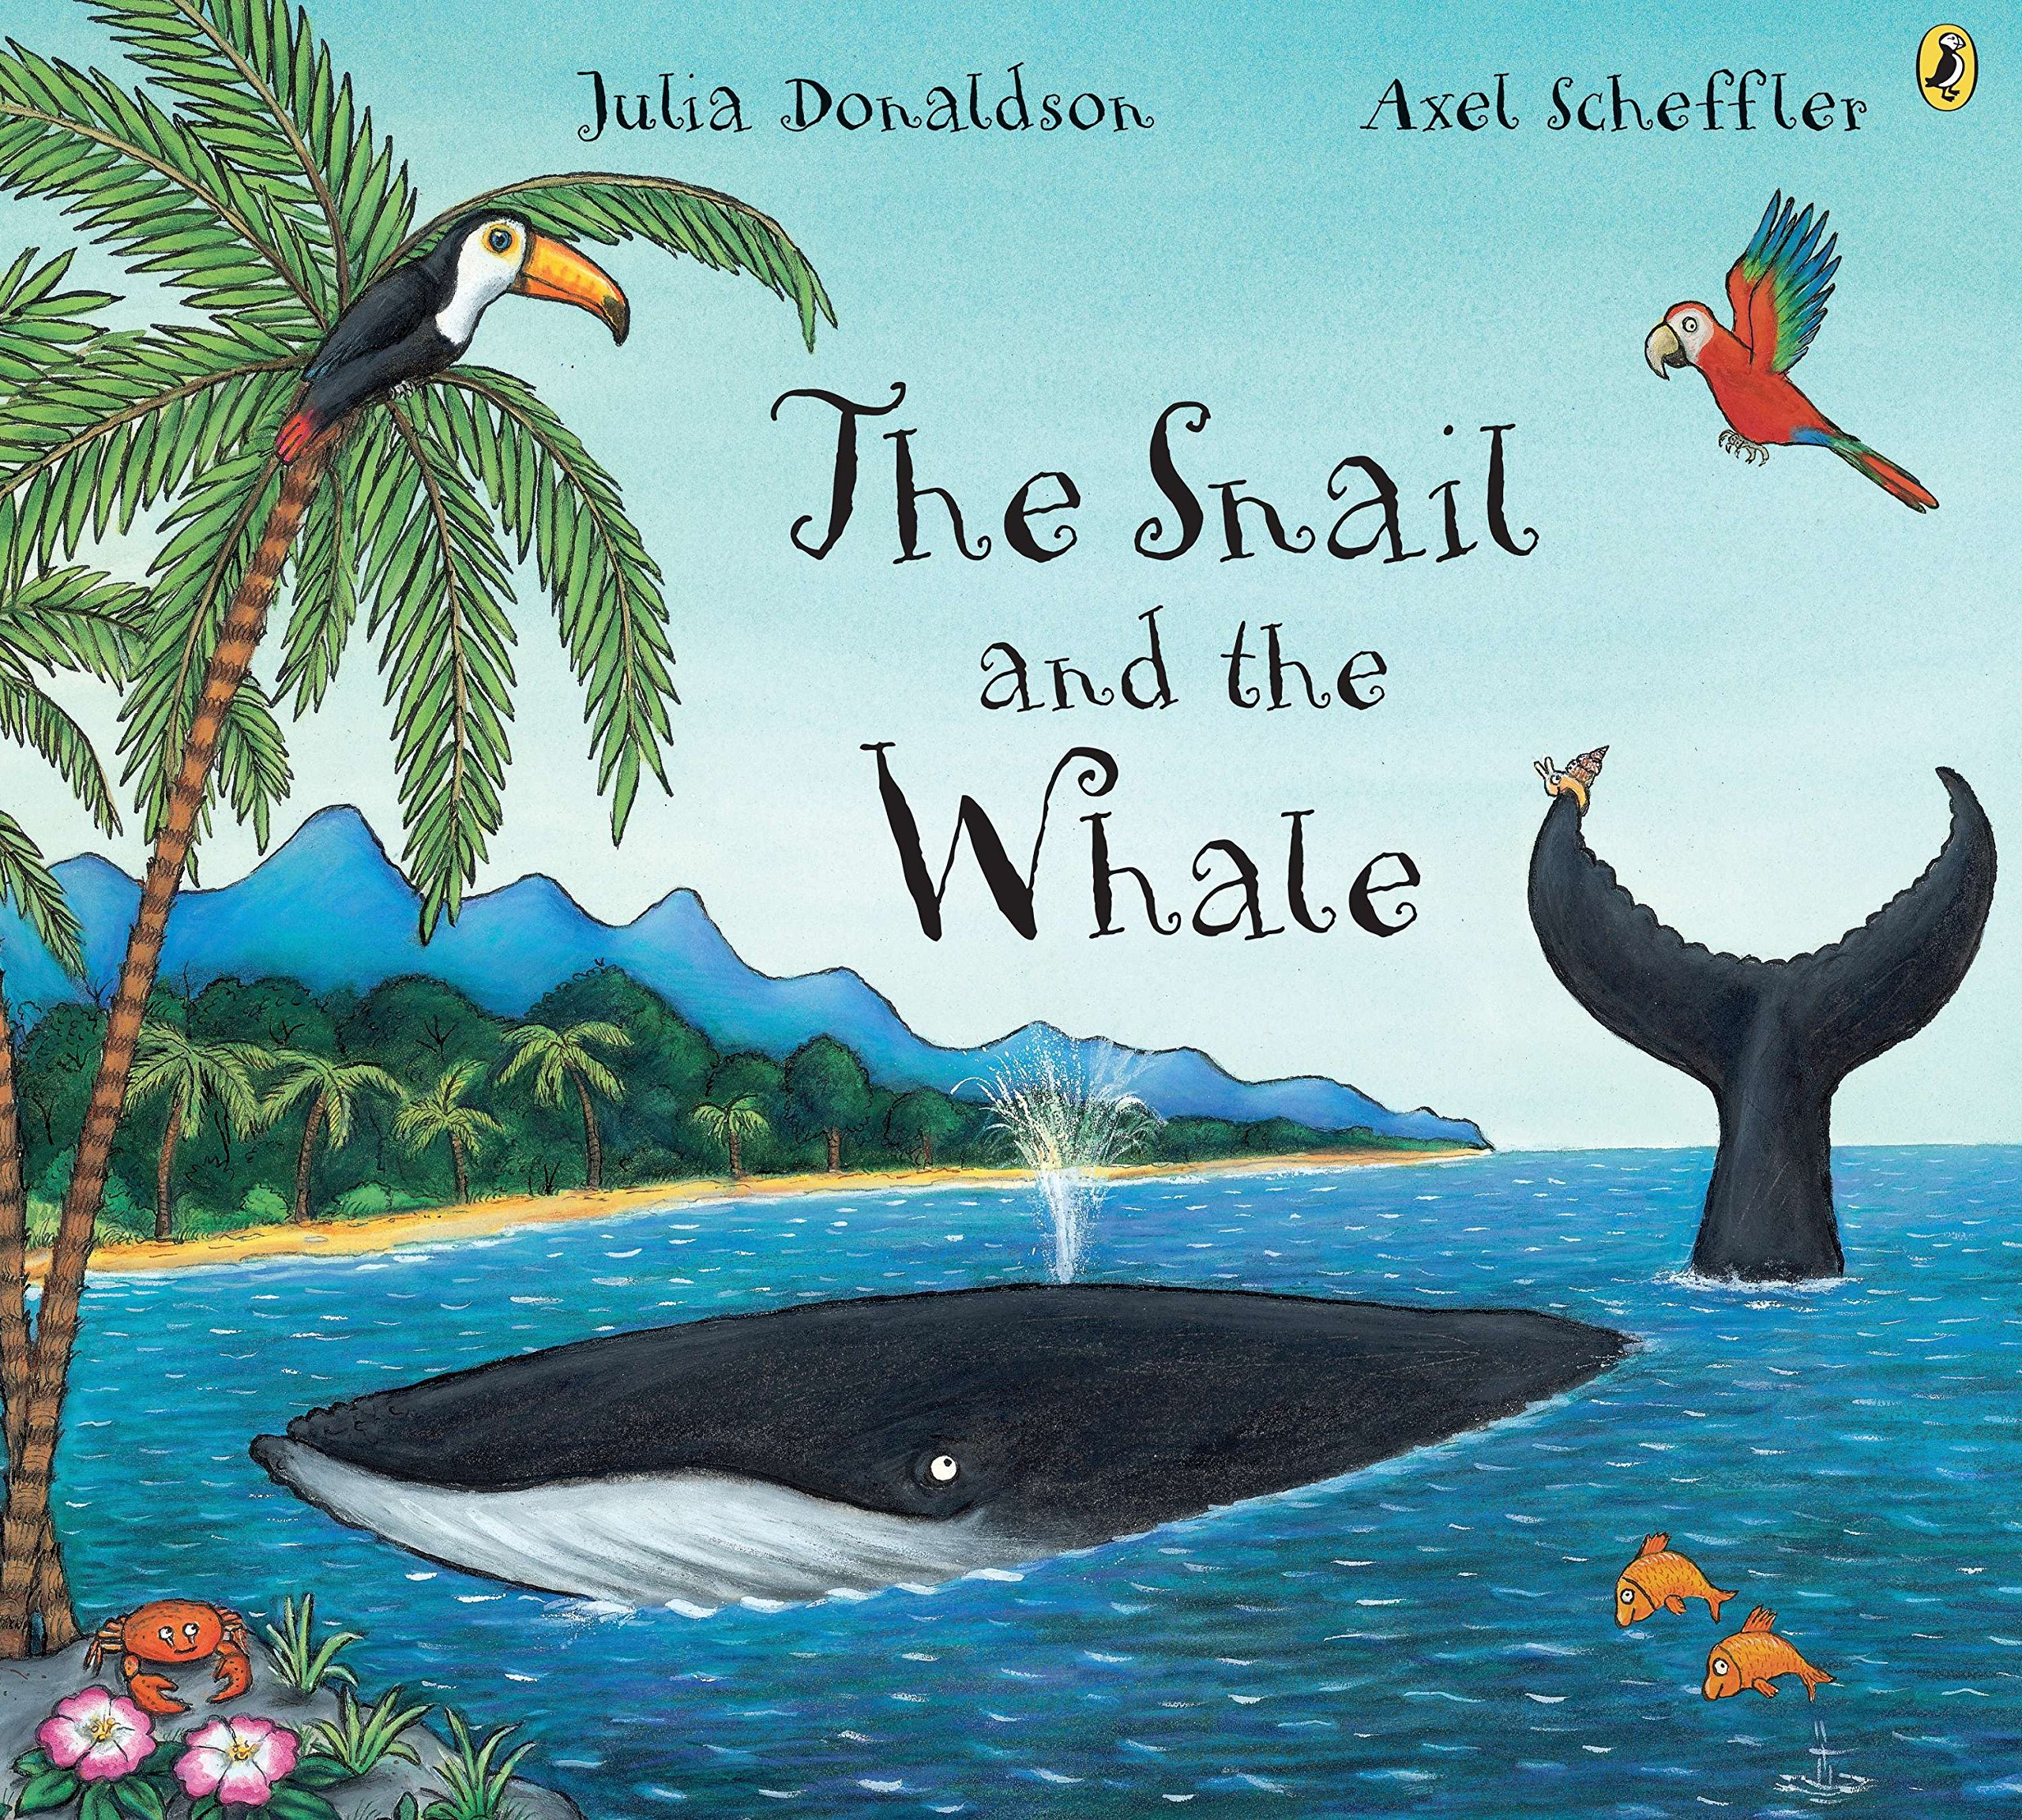

In Read Write Inc this term the children will be continuing with the Read Write Inc programme and will continue to learn different sounds and develop their reading comprehension and writing skills.

Science

During the first half term our topic will be focusing on developing the children’s geography and history skills. After half term we will being out first Science topic focused on animals, including humans.

We will be learning to notice that animals, including humans, have offspring which grow into adults. We will also find out about the basic needs of animals for survival (water, food and air).

Throughout the topic we will also focus on the importance for humans of exercise, eating the right amount of different foods and hygiene.

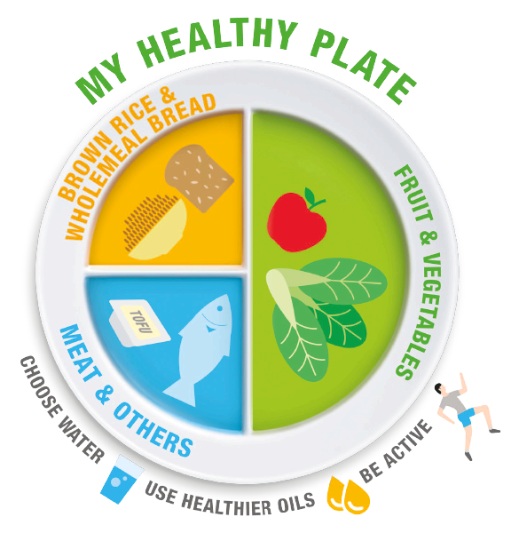

Maths

In Maths this term we will begin by learning about place value and revisiting reading and writing numbers up to 100. We will also be developing our addition and subtraction skills and learning new methods for both operations.

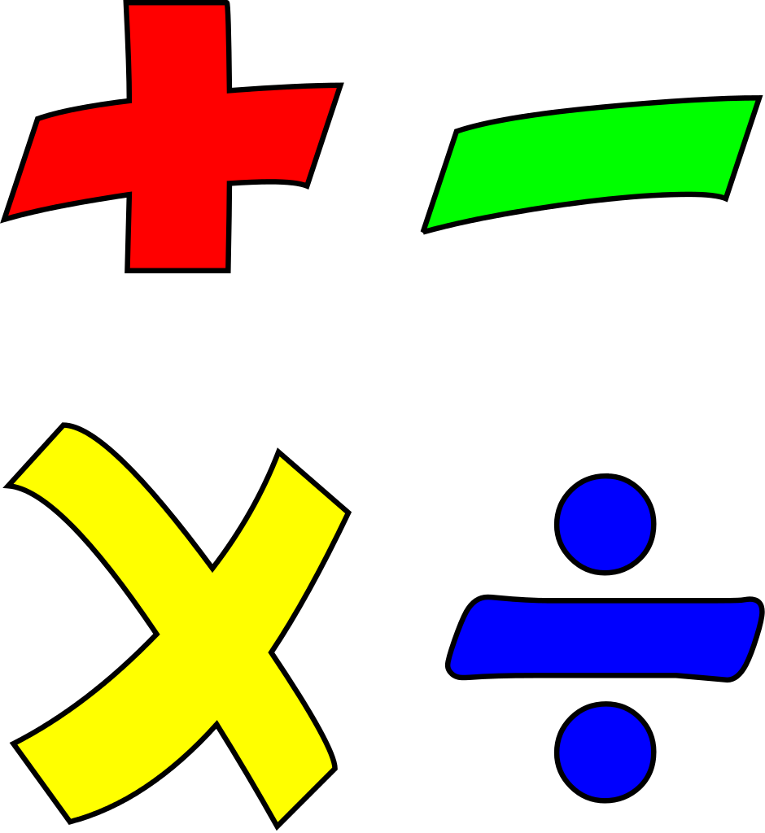

After October half term the children will be focusing on multiplication, specifically the 2, 5 and 10 times tables. We will also be learning how to solve word problems relating to multiplication.

UNCRC
This term we will be focussing on the following Articles:
Article 3 – Adults should do what is best for you.
Article 27 – You have the right to have your basic needs met (safe place, food, clothing).
Article 28 – You have the right to a good quality education.
Article 31 – You have the right to play and rest.



Music

After half term, Miss Stievenard will be continuing her work with the class in music. The children will listen to a variety of styles of music, and they will practise playing a range of instruments.

History

This half term in our ‘Famous Explorers’ topic we will be learning about significant individuals from the past and their lifetime achievements. We will think about what makes someone a ‘significant person’ and how we can find out about their lives.
Art and D.T

In art we will be practising our sketching skills by drawing world maps and focusing on drawing to scale. We will also be learning how to collage using different colours and textures as we work together as a class to create a giant world map.

R.E

After half term, in R.E we will be learning about Christianity and kindness. We will also focus on Christmas and our enquiry question will be ‘What is the good news in the story of Christmas?’

PSHE

In PSHE this term we will be learning about being me in my world. We will be thinking about our hopes and fears for the upcoming term. We will also be thinking about our rights and responsibilities and what it means to be a member of a class and school community. We will also create a class charter which will outline our responsibilities in class.

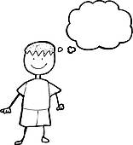

Computing

This half term in computing we will be practising our programming skills. We will be using the Beebots to learn about giving instructions and problem solving.

PE/Games

This term we will be starting a new whole school P.E programme. In Year 2 we will be focusing on balance and footwork. We will be learning how to move around in different ways and how we can use our bodies to create different shapes.

We will also be sending home activity booklets linked to the skills we are learning in class.

Geography

This half term in our topic ‘Famous Explorers’ we will be revising the 7 continents and learning about the 5 oceans. We will be focusing on using maps and atlases to locate different countries and will also learn about hot and cold areas of the world.



