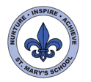
Curriculum Overview
Year One
Summer

English

This half term we will be writing our own riddles as part of our new topic ‘Nature Detectives’. We will be reading the story ‘Meerkat Mail’ and using our knowledge of the world to find the different countries on a map. We will be writing postcards and letters before starting our new story ‘Handa’s Surprise’. We will be writing instructions for our own smoothie recipes and writing poems and narratives too.
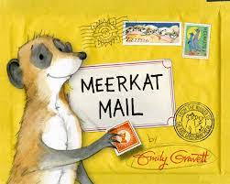

The children will also be looking at how to write non-fiction texts such as fact sheets about plants and animals in their habitat.

We will continue to learn our sounds in our daily RWI lessons and hope to complete learning the Year 1 sight words before the end of Year 1.
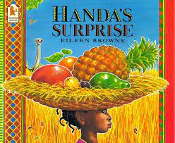

Science

This half term in the children will be learning to identify and describe the basic structure of a variety of common flowering plants and trees.

We have planted some sunflowers and will be gathering and recording data to help us understand how quickly sunflowers grow as well as how the roots of plants help to feed them.
The children will also be visiting the Zoo where they will learn to identify and name a variety of common animals including fish, amphibians, reptiles, birds and mammals.

Maths

In Maths this half term we will continue to use our knowledge of addition and subtraction to figure out one step word problems.

The children will also be learning about multiplication and division. We will begin by solving one-step problems using different resources in the classroom to help us. We will continue to practice counting in 2s, 5s and 10s.

Towards the end of the Summer term, we will be learning to tell the time and recognise fractions, including: whole, half and quarters.


UNCRC
This term we will be focussing on Articles:
5: Learn how to use your rights as you grow up.
6: Your right to life and to be healthy.
12: Your right to say what you think should happen and be listened to.
17: Your right to honest information from newspapers and television that you can understand.
29: Your right to become the best you can be.


PE/Games

In PE we will be focusing on applying physical skills and health and fitness. The children will be able to understand the importance of how our bodies feel before, during and after exercise and perform a range of skills with control and consistency.

The children will also take part in different sports day activities including running, jumping, throwing and team work.
Art

We will be looking at the artist Vincent Van Gough and the work that he did with sunflowers. We will be creating our own versions of still life sunflowers as well as doing some clay work.

Visits and Events

Visit to Hamptonne
Visit to the Zoo
Beach trip
Music

The children will continue listening and responding to a variety of styles of music. They will be using a range of instruments to practise keeping a steady beat.

PSHE

In PSHE this term we will be focusing on the topics ‘being my best’ and ‘growing and changing’. The children will look at how to keep their bodies healthy inside and out and how our bodies have changed since they were a baby. Towards the end of the academic year the children will focus on the ‘Pantosaurous’ (NSPCC) and keeping privates private. We will send out more information regarding these lessons when they are approaching.

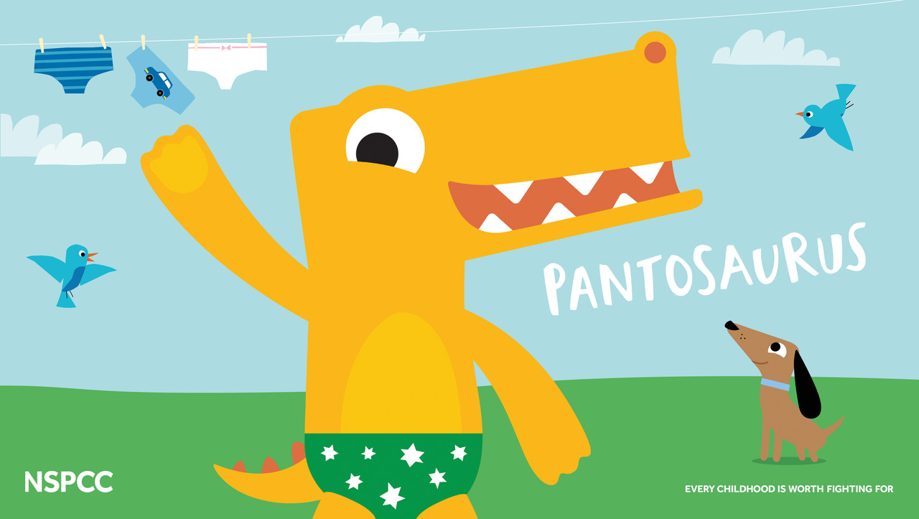
Computing

The children will continue their work in programming robots and using algorithms to complete tasks before looking at grouping data and what technology we have around us. We will also be using the iPads in our geography lessons to use Google maps to find Jersey and the parishes surrounding St Mary.

DT

This half term in DT we will be looking at how to help nature. We will be designing templates of bug hotels before creating them using junk materials.
We will also be using the skills we have learnt during clay making to design and sculpt animal shaped breads.


