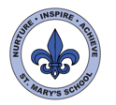
Curriculum Overview
Year One
Spring Term

English

This term we will be focusing on two main books, ‘The Storm Whale’ and ‘Dinosaurs from Head to Tail’. The children will be writing using a range of genres and developing their grammar and spelling.

We will also read and look at a selection of shorter poems about senses and weather which will interlink with our science topics.

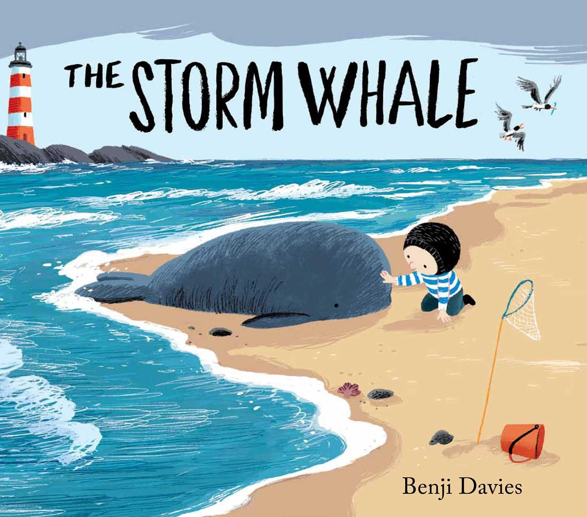

After half term, we will be looking at the series of books ‘The Lighthouse Keeper’. We will be doing some drama and role play along side our English work and writing our own versions of the story as a book. The children will record their story and play these for children in Reception to listen to and create a class movie about one of the books.
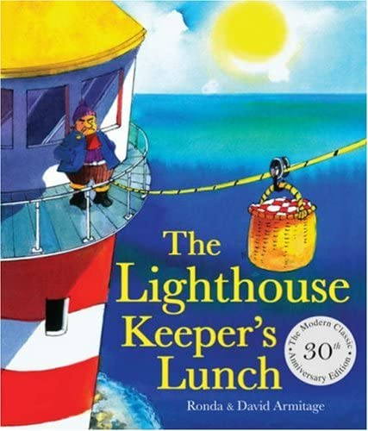
Science

This half term the children will be focussing on seasonal changes in the UK and Jersey. We will be identifying what characteristics each season has and how this can affect us as well as animals and nature. We will continue tracking our weather now that we are in the Winter season and compare what we have already noticed about the Autumn season.

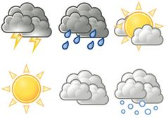

We will also be learning about fair testing with experiments and using tables and graphs to input data we have collected based on weather in Autumn and Winter.

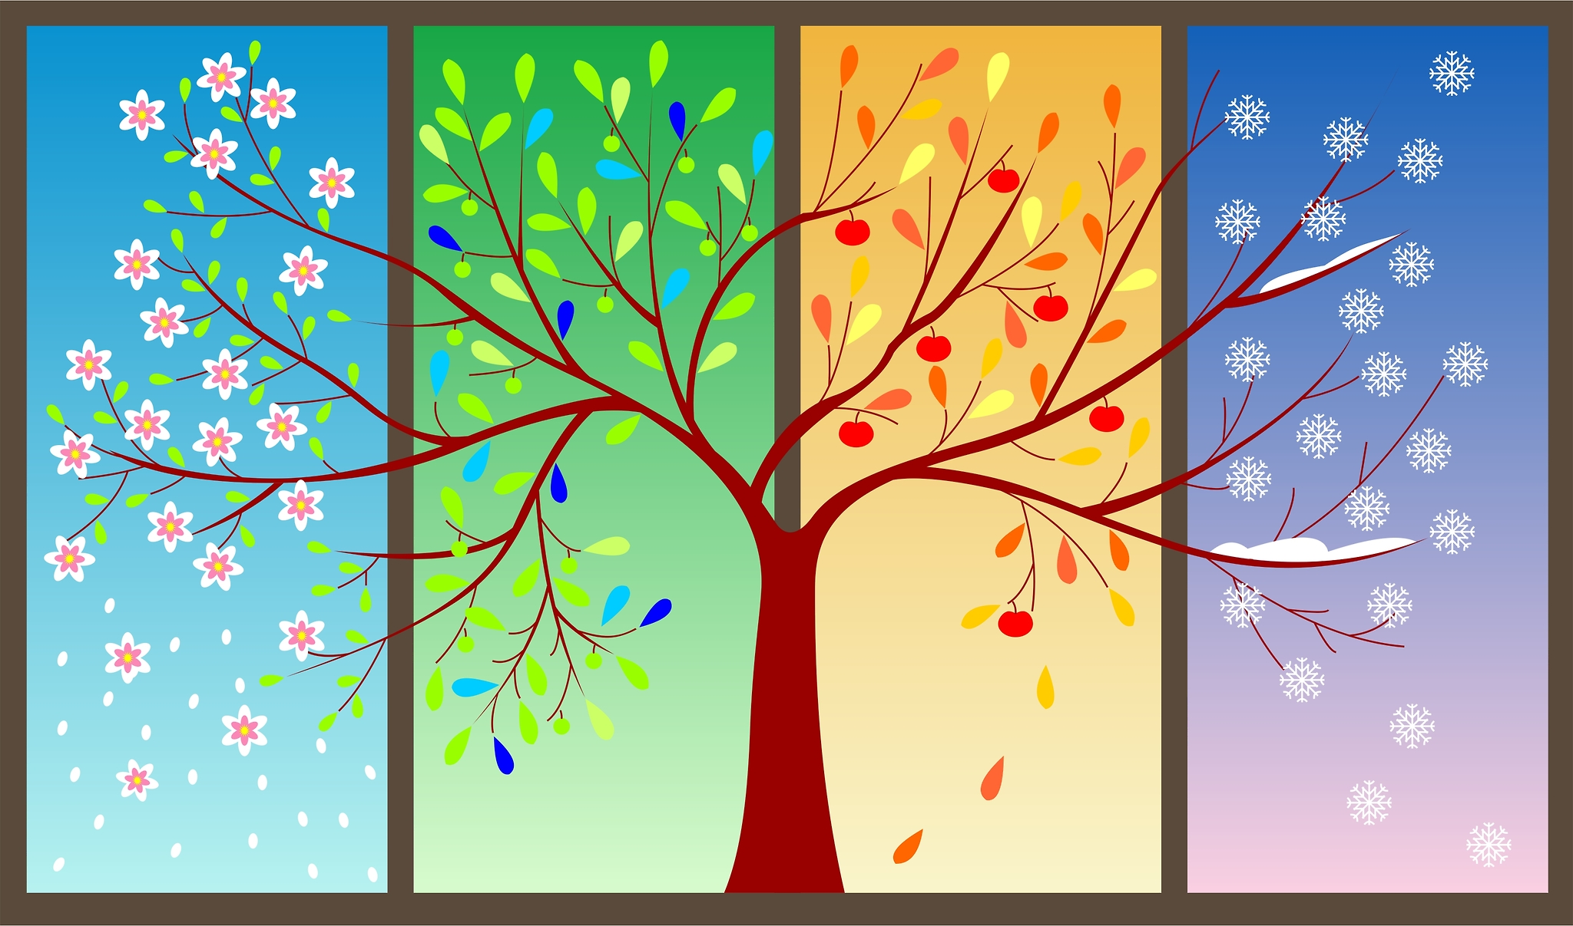

Maths

In Maths this half term we will complete our work on number bonds to 10 and 20, subtraction and addition to 40 and will begin counting in tens and ones. We will also be exploring number patterns and begin using the terms more or less when comparing numbers beyond 40.

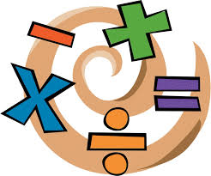

The children will also begin to develop their understanding length and height and will work on using themselves to measure as well as rulers and meter sticks. The children will finish this term by consolidating all their learning they have made so far this academic year.

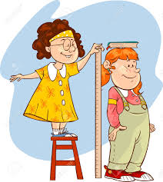


UNCRC
This term we will be focussing on Articles:
5: Learn how to use your rights as you grow up.
6: Your right to life and to be healthy.
12: Your right to say what you think should happen and be listened to.
17: Your right to honest information from newspapers and television that you can understand.
29: Your right to become the best you can be.
36: Your right to be protected from things that could harm you.
37: Your right to be treated fairly if you break the law.

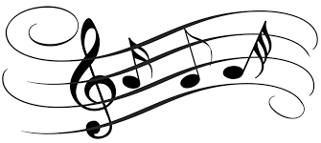
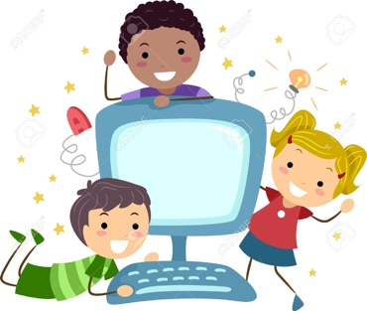
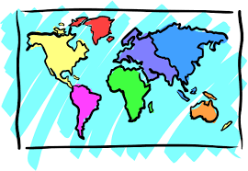
Art

We will begin the term by creating a stain glass window project using tissue paper and magazine cut outs of the different seasons. We will also be using different resources such as oil pastels and salt to explore textures for our season paintings. We will continue our work on ‘Map of Wonders’.

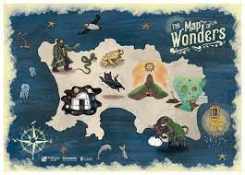

Music

The children will listen and respond to a variety of styles of music. They will practise playing a range of instruments to a steady beat. The children will have Ms Stievenard for both music lessons and singing sessions in assembly.
DT

This half term we will be creating rain gauges to help us collect the amount of rain that falls over the Winter period. This will cross into our science work on seasons which will help us with our data collection.

RE/PSHE

In PSHE this term we will be learning about dreams and goals. The children will be learning to set themselves personal goals and figure out how they can achieve them as well as supporting friends to achieve their goals. The children will be identifying challenges they may have faced or will face at some point and how they can overcome these challenges and fears. Throughout the topic, we will be celebrating our successes and achievements.

In RE this term, we will be looking at different stories that have been told throughout the years and think about the special meaning behind each story. We will be taking a trip to the church to see what happens when Christians are baptised.
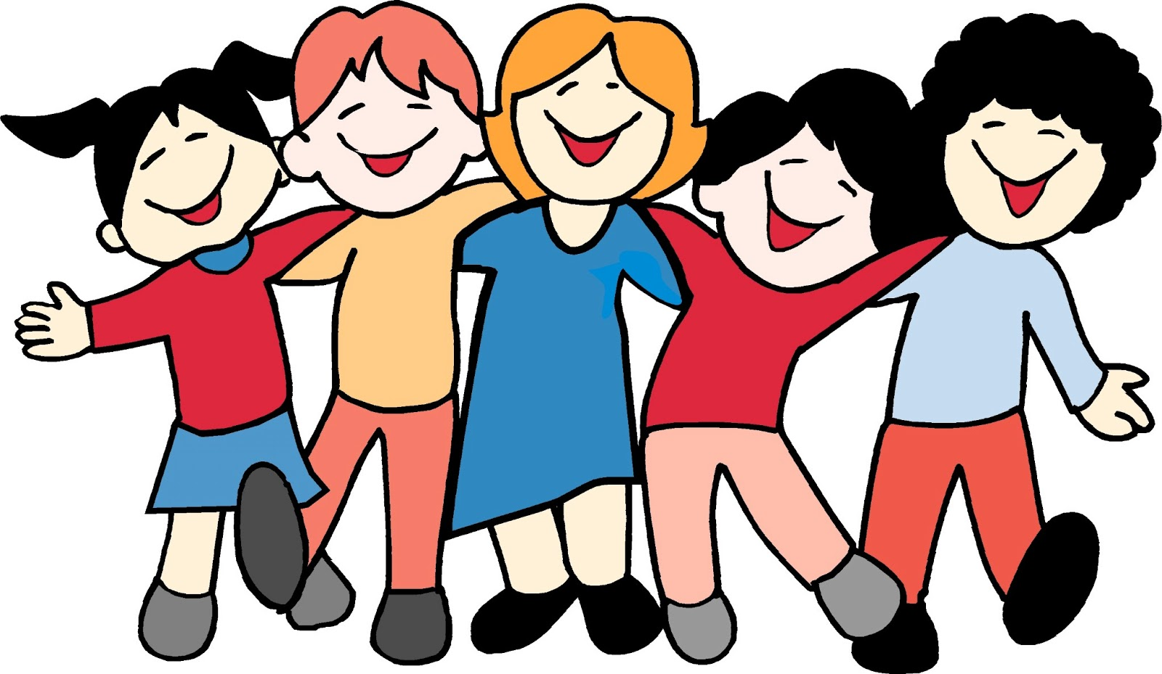
Computing

This half term in computing we will also be using the Bee-bots to help us alongside our geography map work. The children will be learning to programme their Bee-bots to go to different parts of a map and writing down their directions using positional language we will be learning in maths.

We will continue using our knowledge of logging in to the computers to log in to iPads too. We will also be using word processor applications to publish some of our English writing work on poems.

PE/Games

In P.E this half term we will continue using the Real PE programme. We will be focusing on dance, coordination and balance.

We will continue to learn about teamwork and co-operation and what it means to win and lose in sports and games and what traits we have as an individual linking to our RE work.
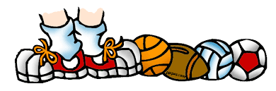

Geography

In geography this half term we will be looking at world maps, atlases and globes to identify Jersey and the Channel Islands. We will be looking at the location of Jersey and the position it is in relation to the UK and France.
We will be learning how to read maps and use those skills to orienteer around the school grounds and thinking about a map that would help us get from home to school. 

