Curriculum Overview
Year One
Autumn Term One

English

This half term we will be reading traditional tales. We will have lots of opportunities to write narratives, letters and work on sentence structure.

We will have a daily focus on handwriting to ensure that the children can form each letter and number correctly.

In Read Write Inc. this half term the children will be learning the set 2 and 3 sounds and continuing to develop their phonic knowledge and improve their reading. The children will be looking at different books including both fiction and non-fiction. We will also be developing their reading comprehension and writing skills.

We will also be working on the Year 1 100 high frequency word list (which will also be sent home). These are words that the children should eventually be able to read at pace without decoding.

Science/DT

This half term we will be designing and creating our own puppets. This project will involve the children selecting the character they wish to bring to life and learning about the properties of materials they could use to create clothing and hair. The children will have a chance to use different tools and equipment in order to create the best possible outcome. Once completed, we will then evaluate our puppets using 2 stars and a wish for how to make improvements in the future.

If you have any material or wooden spoons that you no longer need, we would be very grateful to take them off your hands!

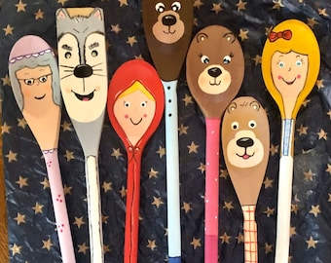
We will also begin our whole year topic based on seasons. We will be doing this throughout the whole year and will be begin our focus on the season Autumn. We will be recording the weather as well as making our own rain collectors using plastic bottles.

Maths

In maths this half term we will begin by learning the number bonds to 10 before developing this to 20. We will also be looking at addition and subtraction to 20 and how number bonds can help us to do these calculations.

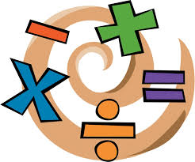

To finish the half term, we will create our own addition and subtraction stories using the knowledge we have gained within the 7 weeks and try different challenges to push the children further.
The children will also be developing their journaling by reflecting on what they have been taught each lesson and journal their thoughts and feelings daily.
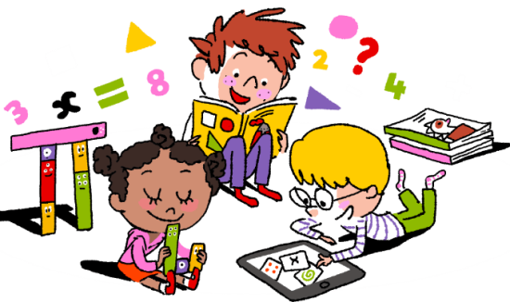

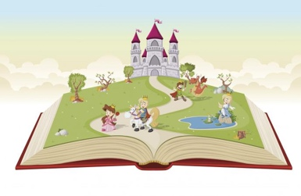
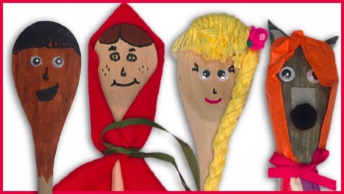

UNCRC
This term we will be focussing on Articles:
5: Learn how to use your rights as you grow up.
6: Your right to life and to be healthy.
12: Your right to say what you think should happen and be listened to.
29: Your right to become the best you can be.
36: Your right to be protected from things that could harm you.

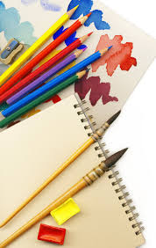
PE/Games

Our school is beginning a new PE approach following the programme Real PE. We will begin looking at coordination and balance and then moving in to dynamic balance to agility and static balance after half term. Children will also have access to the online home version where they will be able to take part in different games at home and challenges within the family.
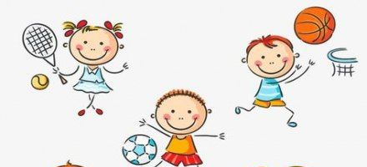
RE

In RE this term we will be thinking about the word ‘belonging’ and where we belong in society and our families. We will also be thinking about what is special to us and our families and which buildings might be special to certain people.
We will finish the half term with a dress up day where the children will be asked to wear an outfit which shows they belong to something e.g. rainbows, sports clubs etc.

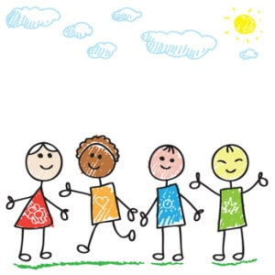

PSHE

In PSHE this term we will be learning about the topic ‘Being me in my own world’.

The children will also be focusing on sharing ideas within the class as well as turn-taking and understanding the different opinions we have within our class.

We will also be creating our own class charter looking at what behaviours are suitable for Year 1.
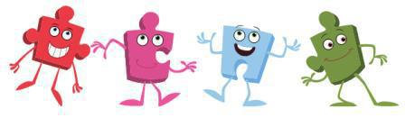

History

Our history topic this term is called ‘Being Me!’ We will be looking at our own family history and what historic events have happened during our lives so far. We will be creating our own family trees and talking about what ‘precious’ means to us. We would love to see pictures of your family recipes and even try some cooking of our own at school. We will also think about our futures and what we would like to be when we grow up. The children will begin to learn new vocabulary such as future, present and past. We will be looking at how time has changed and the difference between our toys and childhood compared to our grandparents. If you have any stories from the past that you would like to share with us please do! We would love to hear them.
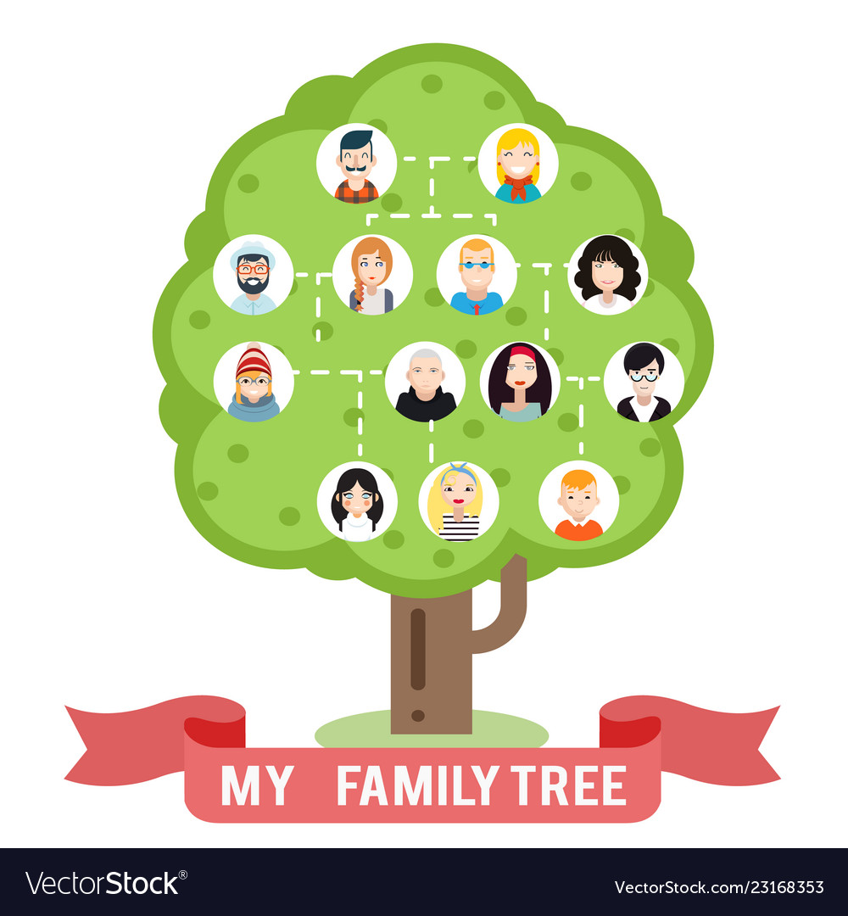

Art

In art this term we will be creating multiple pieces of work by exploring with paints, wax crayons and charcoal to build up an awareness to the different resources that are available in school. We will also be trying papier-mache as well as using clay and salt dough to create small sculptures related to our fairy tale topic.

