

St Mary’s School
Counter-Bullying Policy

(This policy should be read in conjunction with CYPES Counter Bullying Policy 2019)
UNCRC Article 3: Everyone who works with children should do what is best for each child.
UNCRC Article 19: You should not be harmed and should be looked after and kept safe.
UNCRC Article 37: If you do the wrong thing, you have a right to be treated fairly.

1. Introduction
Research shows that by the time they leave school at 16 years of age, around 50% of pupils will experience bullying at least once during their schooling. The role that staff play, and the way that bullying is perceived by the pupils, both have a significant impact on the prevalence and frequency of bullying acts in school. We aim to engage staff, pupils and parents together in creating a bully-free and respectful learning environment.
2. Scope
This document describes our approach to dealing with incidents of bullying. It also offers a whole school perspective on developing a counter-bullying culture and effective practices. Staff should read this document in conjunction with the IEI document ‘Counter-Bullying – Guidelines for School Staff’ (available in staff policies file) which provides comprehensive guidance for schools in responding to and supporting children who bully or are the victims of bullying.
3. Aims
This policy aims to:
- Increase staff understanding and awareness of the main issues around bullying
- Increase staff’s confidence in managing a bullying situation effectively
- Guide staff in dealing with bullying situations appropriately
- Understand how to deal with reporting and accusations of pupil bullying
- Ensure all parties involved in the bullying event are supported appropriately
4. Definition of Bullying
We adopt the definition of the Anti-Bullying Alliance:
‘Bullying is a subjective experience and can take many forms. To be classed as a bullying act the perpetrator needs to have a social and premeditated awareness that the act is malicious and will cause physical and or emotional harm.’
Accounts of children and young people, backed up by research, identify bullying as any behaviour that is:
- Emotional and physically harmful, carried out by an individual or a group
- Deliberate and wilful with a premeditated intent to harm
- Occurs more than once
- An imbalance of power, leaving the person being bullied feeling threatened.
Children and young people or adults can instigate bullying and each can be bullied, in any combination. Research shows that two-thirds of children who bully others do so because they themselves are being bullied elsewhere. Hence educational establishments need to consider potential bullying in relation to child-child; adult-child; child-adult and adult-adult scenarios. St Mary’s School is committed to challenging any form of bullying within the staff team and any incidents will be addressed in line with Government of Jersey Policies.
5. Types of Bullying
Bullying generally takes the form of emotionally or physically harmful behaviour. It can include any of the following: name calling, taunting, threats, mocking, making offensive comments, kicking, hitting, pushing, taking and damaging belongings, malicious gossiping, excluding people from groups, and spreading hurtful and untrue rumours. It may include homophobic, transphobic or biphobic bullying. These activities can take place face to face, via third parties, or via other means such as text messages, emails, blogs, gaming websites, internet chatrooms, instant messaging and camera facilities. The nature of bullying is changing and evolving as technology develops.
FORMS:
There are two forms of Bullying: Direct and Indirect.
Direct bullying is classed as the process of carrying out an act of bullying as described above. A person can be accused of direct bullying if they proactively engage in acts that involve ‘actual’ harm of another person emotionally, socially and/or physically.
Indirect bullying is by means of incitement and other forms of the ‘encouraging and supporting’ of others to harm or bully another person. Examples of this include passing on messages, liking on Facebook or other media; watching physical acts without action and any other means of facilitating acts of aggression and harm.
TYPES:
Different types of bullying include:
Physical – hitting, kicking, tripping someone up, stealing/damaging someone’s belongings
Verbal – name-calling, insulting a person’s family, threats of physical violence, spreading rumours, constantly putting a person down
Emotional/Psychological – excluding someone from a group, humiliation, encouraging hate, highlighting differences and highlighting weaknesses
Racist – insulting language / gestures based on a person’s actual or perceived ethnic origin or faith, name calling, graffiti, racially motivated violence, use of racial motived imagery
Sexual – sexually insulting language / gestures, name-calling, graffiti, unwanted physical contact, encouragement of posting inappropriate photographs and other material
Homophobic – insulting language / gestures, name-calling based on a person’s actual or perceived sexuality, name-calling, graffiti and homophobic violence
Electronic/Cyber – bullying by text message, bullying on the internet (in chat rooms, on bulletin boards and through instant messaging services), hate websites, using photographs, happy slapping etc.

6. Creating a culture of counter-bullying
It is the responsibility of every member of our school community, regardless of role, status or age to facilitate a culture of non-aggression and emotional support in school. Levels of bullying are greatly influenced by cultural norms and expectations as well as relationship modelling between individuals and groups of all ages. Indirect bullying is fostered by apathy and inaction and is recognised as one of the most prevalent forms of bullying in any community. We must endeavour to ensure that everyone on site shows equal measures of support and challenge to those who bully others. Anti-bullying week is an opportunity to focus some specific work around bullying in school, but creating and maintaining a counter-bullying culture in school is a priority all year round. Our expectations are visited regularly through assemblies, class discussions, small group interventions, school council support and PSHE lessons throughout the year.
7. The role of parents and carers
When incidents of bullying are identified, parents will be involved in the resolution. The parents of the child who bullies and the parents of the victim will be invited to meet with the school to explore and agree the best way forward. The support of parents for all children involved will be key to a resolution.
8. Reporting and Recording
Not all acts of aggression can be classed as bullying therefore the school needs to investigate all incidences thoroughly to determine whether it can be recorded as bullying or needs to be recorded under another behaviour category. If it is appropriate to label the incidence as a bullying, the Counter Bullying Lead will identify the type. From April 2023 all bullying incidents will be logged on MyConcern.
9. Support for staff
It is recognised that some members of staff will find responding to a bullying situation as challenging, particularly when they may need to intervene to safeguard the pupils involved. All staff should be given support and training on a regular basis through INSET, staff meetings and access to central training provided by Education Department. The main focus of intervention should be de-escalation and keeping pupils safe in the first instance. Care and consideration needs to be given if direct intervention is needed and appropriate training should be provided to help manager these situations.
10. Other considerations
It is important to note that research shows that two-thirds of bullying goes unreported in school and the majority of the bullying incidences occur within the school building. Staff should not underestimate the effects of bullying on the individual from emotional distress to poor concentration and disruptive behaviours. Warning signs like unwillingness to participate, social isolation and oversensitivity to comments and praise can all be possible indicators of bullying (as well as other matters). A key indicator of bullying can be seen as a significant rise in pupil distress coming up to a transition point in the lesson/ school day. All staff need to be aware of the possible signs of distress, particularly when there has been a sudden change in behaviours and presentation in a pupil. Bullying occurs in every school and in every year group. Disregarding this fact facilitates bullying in your school and attitudes of it being ‘normal’ or ‘healthy’ are forms of indirect bullying and should not be tolerated.

11. Monitoring, evaluation and review
The counter-bullying lead will monitor the Bullying Log in Teacher’s Shared regularly and report figures termly to the Education Department from January 2020. The findings will be taken into consideration when prioritising whole school developments.
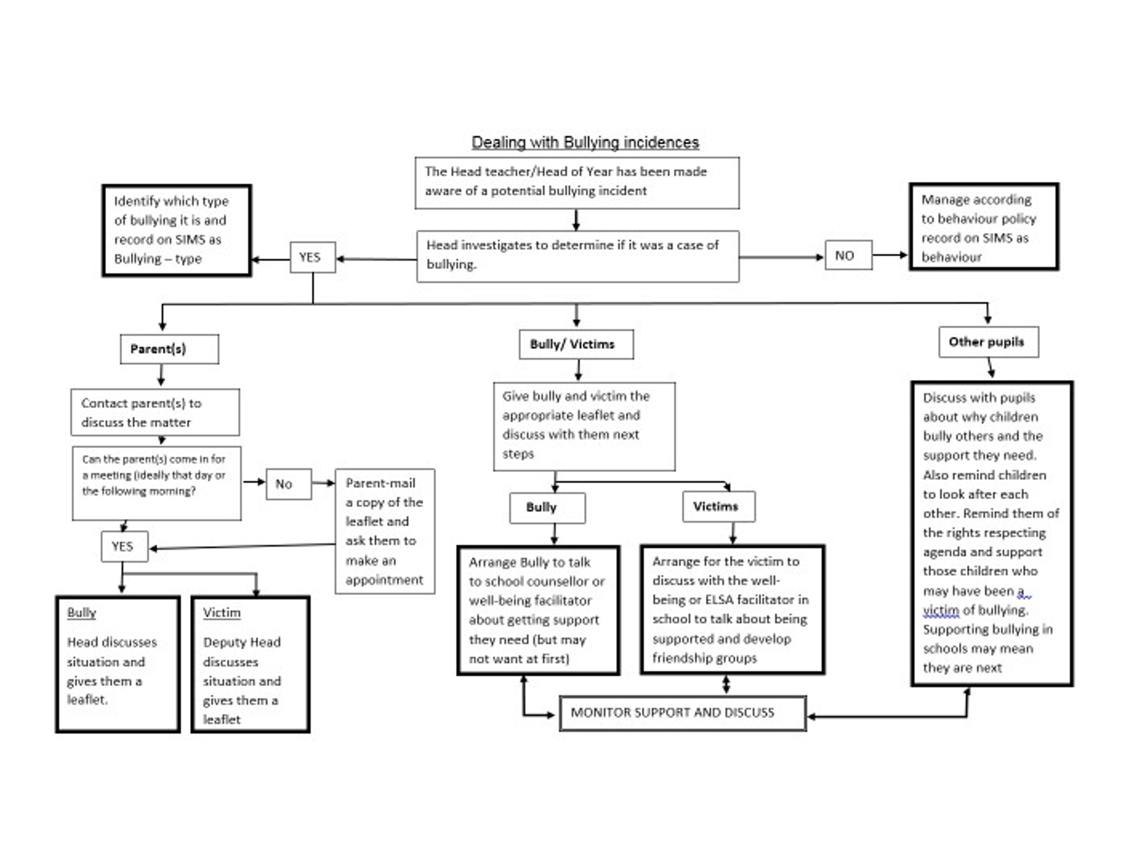
Policy updated: December 2022
Review Date: December 2023

