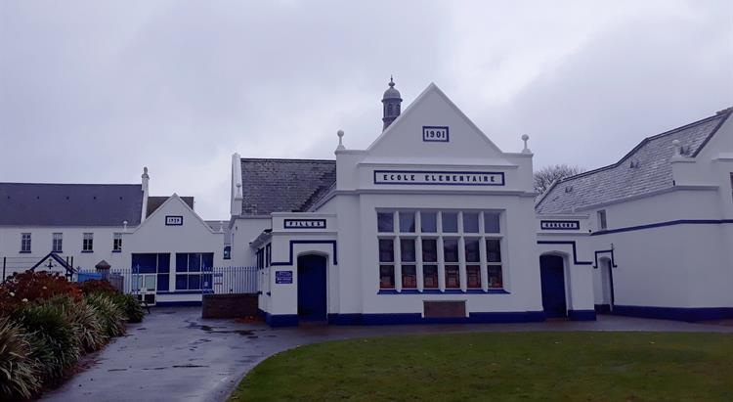



St Mary’s School SEN Report
Sept 2023 – July 2024
Article 3 - All adults should always do what is best for you.
Article 23 - If you are disabled, either mentally or physically, you have the right to special care and education to help you develop and lead a full life
What is SEND:
The term ‘Special Educational Needs’ is used to describe learning difficulties or disabilities that make it harder for children to learn than most children of the same age. Children with special educational needs and/or disabilities (SEND) are likely to need extra or different help from that given to other children their age.
What provision is made at St Mary’s School:
St Mary’s School aims to be an inclusive school where all children, parents/carers, staff and other community members feel valued and involved. We actively seek to remove the barriers to learning and participation that can hinder or exclude individuals, or groups of pupils. Providing equality for all of our children is a priority for us. We make this a reality through the attention we pay to the different groups of children within our school regardless of:
- Gender
- Any identified SEND
- Ability
- Differing family structures
- Risk of disaffection or exclusion.
We have made provision for pupils experiencing difficulties in each area of need described in the Jersey SEN Code of Practice 2017. These are:
- Communication and Interaction
- Cognition and Learning
- Social, Emotional and Mental Health Difficulties
- Sensory and/or physical needs
Vulnerable Groups at St Mary’s
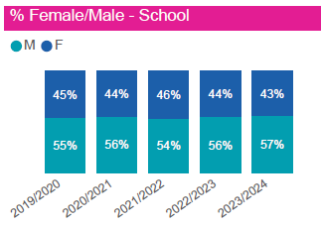 |  |  | 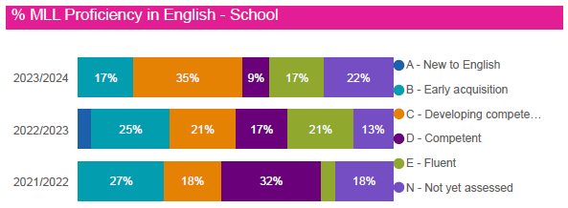
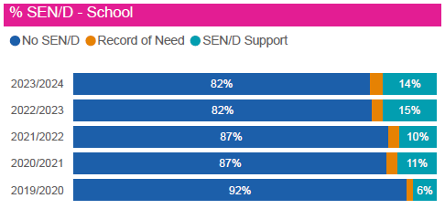 |  |  | 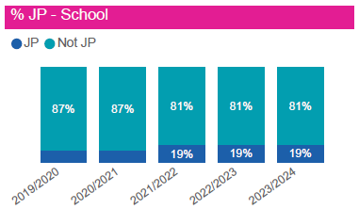
 | Total pupils | Total pupils with SEND |  | SEND pupils with SEN Support | SEND Pupils with a RoN
Year 2023-2024* | 158 | 19% |  | 15% | 4%

Year 2022-2023* | Communication and Interaction needs  (Including speech and language, ASD - Autism Spectrum Disorder) | Cognition and Learning needs | Social, Emotional and Mental Health Difficulties  (Including ADHD - Attention Deficit and Hyperactivity Disorder) | Sensory and/or physical needs
Percentage of SEND children with: | 43% | 40% | 67% | 13%

*(As of July 2024)

SEND Roles and Responsibilities:
At St Mary’s, all staff have a responsibility for SEND within the school.
During the 2023-2024 academic year, the SENCo was Lisa Harber.
SENCo’s responsibilities include:
- Providing support and guidance to all staff
- Setting up provision maps and pupil profiles and supporting all staff in their use and the updating of these.
- Monitoring and evaluating SEN support in place and planning next steps.
- Deployment of support staff, including the timetabling of keyworkers and teaching assistants.
- Monitoring attainment and progress through pupil progress meetings and data analysis.
- Referrals and assessments for outside agency support and meetings.
- Meetings with parents
- Leading Annual Review meetings
- Ensuring the code of practise is adhered to
- Delivering CYPES guidance to staff.

Class/Subject teacher responsibilities include:
- Ensuring differentiation, adaptations and support are in line with pupils’ needs, outlined in provision maps
- Updating and monitoring of pupil profiles and provision maps.
- Conversations/meetings with parents.
- Noting initial concerns and adjusting classroom practise to help overcome these.
- High quality teaching
- Deployment of keyworker/teaching assistants in their classroom.

Last year we had 8 support staff and keyworkers who worked alongside many SEND pupils to ensure that they could access the curriculum, achieve individual targets and they also supported behaviour and emotional needs. This included working with groups, individuals and in the classroom supporting the teacher.

Identifying and Assessing Children with SEND:
Teachers support pupils to work within the expected age-related objectives, where possible, regardless of their needs. Learning is adapted to support pupils and allow for a variety of learning styles.
We aim to identify SEN needs as they arise through:
- Teachers’ assessments, which may show that a child is not making expected progress
- Observations
- Discussion at pupil progress meetings
- Parental concerns

Initially, teachers will use a range of strategies to support children making slower or little progress before suggesting a child has SEND, using the Ordinarily Available document to support them.

Assessing Children for SEND
There are a limited number of assessments we use in school to help identify if children may have SEND. These are not diagnostic assessments but help us to identify if there are any areas which a child may be finding difficult and set targets to help children improve. The following tools are used:
- JLAIT – Literacy based assessment
- WELLCOMM – Language and communication assessment
- ELSA Assessment – Wellbeing
- Benchmark reading assessments
- Yark Reading Assessments

Parent Consultations
Conversations between parents and school are crucial to identifying if a child has SEND. We endeavour to let parents know as soon as concerns have been noted. These consultations can be informal meetings at the end of the school day or in twice termly parent consultations. Many of these concerns will be short-lived and can be addressed by class teachers. However, if little progress is made following intervention, teachers will discuss these concerns with the Special Educational Needs Coordinator.
We encourage all parents to speak to their child’s class teacher if they have a concern. If they would like to speak to the SENCo, appointments can be arranged by phoning or emailing the school office.
Communication with parents is vital when children have been identified as having SEND. This is done through twice termly parent consultations, which are an opportunity for teachers and parents/carers to look at the progress pupils have made. If a SEND child has a Pupil Profile, Consistent Management Plans and/or Handling Plan, these will also be shared with parents/carers every term, often during the parent consultations. Further communication with parents/carers was through informal, in some cases daily, meetings, emails and communication books.
If a child needs support from an external agency, parental consent is achieved through a conversation involving the class teacher and SENCo. Parents and SENCo sign a consent form, which contains information about the child and the desired outcomes of the support for the child at school.

The Approach to Teaching Children with SEND
In all classes, high quality teaching is the priority for supporting children with SEND. Additional provisions may be put in place to help a child with SEND to access this teaching. These may include:
- Scaffolding – this involves techniques to provide children with support, that can be gradually removed to give them independence in their learning.
- Support/advice from outside agencies, which is then implemented in school
- Highly focused lessons designed with sharp objectives
- High demands of pupil involvement and engagement with their learning
- High levels of interaction for all pupils
- Appropriate use of questioning, modelling, and explaining on the part of the teacher
- An emphasis on learning through dialogue, with regular opportunities for pupils to talk both individually and in groups
- An expectation that pupils will accept responsibility for their own learning and work independently
- Regular use of encouragement and authentic praise to engage and motivate pupils
- Additional adult support in lessons
- Interventions to enable children to make progress in areas they are finding difficult. This would normally be outside the classroom
- Alternative ways to record their work – taking photographs etc
- Practical resources and adaptations to the environment – such as standing desk, wobble cushions, fidgets etc
- For SEND children working significantly below their age-related expectations – they may have an alternative curriculum

Interventions
To support pupils who are not making expected progress, we may run interventions. These can include:
- Maths and reading groups
- WELLCOMM interventions for language and communication
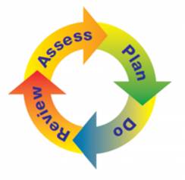
- ECOF reading
- RWI intervention
- Hertfordshire Reading Intervention
- Precision Teaching
- ELSA – Emotional literacy and wellbeing
- Lego Club
- Healing Waves – Surfing Sessions

Evaluating the Effectiveness of Provision for SEND Pupils
Targets for pupils with SEND are reviewed each term and provision maps are updated. New targets are set by teachers and shared with parents. The school adopts an Assess, Plan, Do, Review process:
Assess – this involves taking into consideration all the information from discussions with parents/carers, the child, the class teacher and assessments.
Plan – this stage identifies the barriers for learning, intended outcomes, and details the additional support that will be provided to help overcome the barriers. Decisions are recorded on an SEN Provision map and form the basis for review meetings.
Do - provide the support – extra assistance for learning – as set out in the plan.
Review – measure the impact of support provided and consider whether changes to that support needed to be made. All of those involved – learner, parents, teacher, SENCo and outside agencies contribute to this review when necessary. This stage then informs the next cycle of provision mapping and one-page profiles.

Attainment for SEND Pupils in 2023-2024
We measure the attainment of all children in the school in reading, writing and maths. Below is the attainment for children with SEND at the end of the 2024 academic year.

 | Attainment in Reading for SEND pupils in KS1/2 | Attainment for Writing for SEND pupils in KS1/2 | Attainment in maths for SEND pupils in KS1/2
Secure + | 0 | 0 | 3%
Secure | 31% | 17% | 24%
Developing | 34% | 41% | 34%
Emerging | 28% | 24% | 31%
Out of year group | 7% | 17% | 7%

Emotional and social development
Pupils are supported to improve and maintain their emotional and social development. This can be through PSHE lessons, assemblies and intervention programs.
Our PSHE scheme SCARF (Safety, Caring, Achievement, Resilience, Friendship), is a progressive scheme which helps develop children’s wellbeing and mental health. Children have PSHE lessons each week. PSHE is led by Lisa Harber, who also leads school in UNICEF’s Rights Respecting work.
For children who may need more than this, access to sessions with our ELSA (Emotional Literacy Support Assistant) can be arranged. Mrs Betts is our school ELSA and she supports pupils in 1:1 sessions through a planned programme aimed at helping them in the areas they may be struggling. Teachers who have concerns about a child’s mental health and wellbeing, will refer to the SENCO and ELSA.
We also have access to outside agencies, who can support children with mental health. Referrals can be made to the Wellbeing Facilitator Team, CAMHS Early Intervention Team, Therapeutic Art (Kairos), CAMHS and MIND Jersey. Any parents who are concerned about their child’s mental health, are encouraged to speak to their child’s class teacher in the first instance.
Last academic year, we had a high number of children who received wellbeing/mental health support. This has been a growing trend since COVID. In 2023-2024, 44 children were supported through either ELSA or external wellbeing support. Where possible we try to support children in groups, for example Nurture Groups with Miss Betts, or Befriending Anxiety groups with CAMHS EI Team.

Engagement in other activities
We are an inclusive school and attendance in school clubs and participation in all activities is encouraged. When trips are planned, additional risk assessments are put in place for pupils with SEND, who require additional support. These arrangements are discussed with parents to ensure that SEND children have appropriate arrangements wherever possible.
Transition Support
Children with SEND may find transitioning from one class to another, or between schools, quite difficult. Every effort is made to support pupils during this time. When transitioning between classes, pupils with SEND will often have additional opportunities to get to know their teacher and a meeting will take place between their current teacher and new teacher to ensure that they have all the information needed. Some children with SEND will be given a transition booklet, with photographs and important information, to help them prepare for the changes they will face.
When children with SEND transfer to another school, the SENCOs from both schools will meet to discuss the child’s needs and plan the transition process. Parents and children will be fully involved with this process. If children require additional transition support, they may have additional visits. The transition for pupils who have a Record of Need, will be discussed in their Annual Review. Year 6 pupils’ Annual Reviews take place by the end of November in their last academic year.

Expertise of Staff
At St Mary’s School, we have regular training updates in staff meetings. Some of these focussed on special educational needs to make sure that every member of staff:
• Understands the different special educational needs
• Is familiar with the child protection policy and its procedures.
• Knows how to support the needs of children with SEN.
• Understands attachment issues
• Knows how to plan and teach their lessons in a way that is appropriate for children with special educational needs

During 2023-2024, the following training took place for some/all staff:
- SENCo – Safeguarding, SENCO meetings
- Support Staff - Safeguarding, First Aid, Speech and Language, RWI tutoring
- All Staff - Safeguarding, Mental Health, supporting children with ADHD, MAYBO
- ELSA – ELSA training sessions termly, ELSA conference

External Agency Support
Sometimes a child will have needs that require input from a specialist outside the school. We have access to the following support:
- Wellbeing Facilitator Team
- Educational Psychologist
- Social Emotional Mental Health Inclusion Team (SEMHIT)
- Education Welfare Officer (EWO)
- Autism and Social Communication Inclusion Team (ASCIT)
- Speech and Language Therapists
- Occupation Therapy Team
- Visual Impairment Team
- School Nurse
- Children and Adolescent Mental Health Service (CAMHS)
- Children and Adolescent Mental Health Service Early Intervention Team

Outcomes of School Priorities for SEND pupils in 2023-2024.
To raise awareness and understanding of SEN with pupils and parents:
- During the year, information was sent out to parents to explain the SEND Register, it’s purpose and how the information is used.
- Parent coffee morning focusing on children with neurodivergent needs
- Assembly focussing on celebrating neurodivergent differences

Sign Posting for Parent Support
For further information about the support available for children with SEND in schools, please click on the image below:
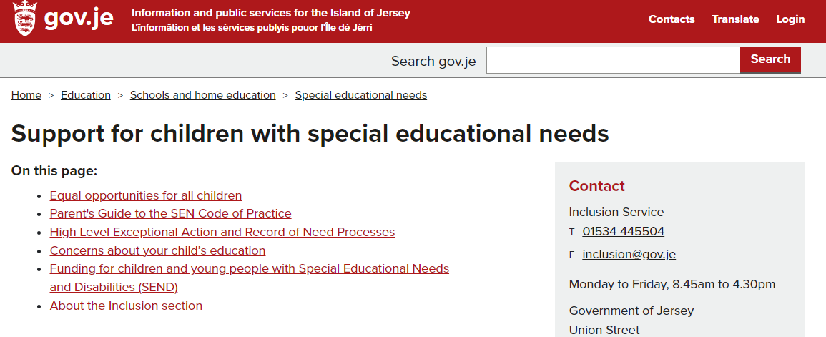

Additional general support can be found on the Children and Families Hub (click on the image below):
Here, parents can find a directory of agencies that can be contacted in order to provide support for a wide number of areas.
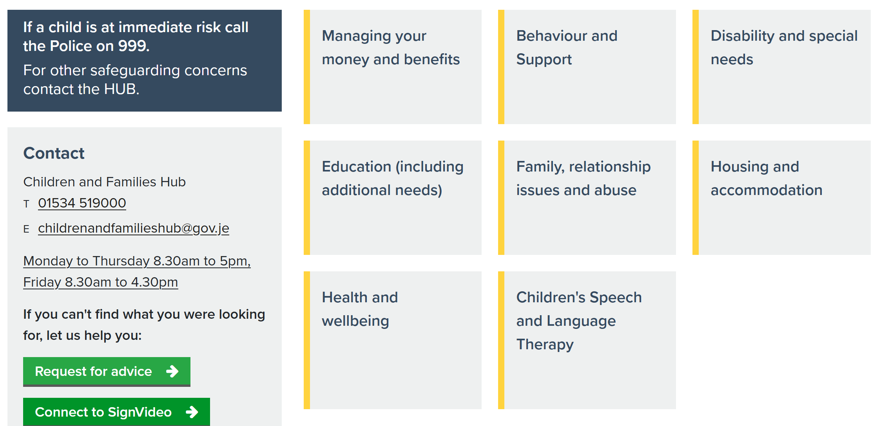

Handling complaints
School Compliment and Concerns policy is available from school and off the school website.
When parents have a concern about the support around their child, the first point of call is their child’s class teacher. If they would like to speak to someone else, then we would encourage parents to go to their child’s Key Stage Leader.
- Early Years Leader: Sarah Le Moignan
- Key Stage 1 Leader (Years 1 & 2): Laura Webb
- Key Stage 2 Leader (Years 3,4,5 & 6): Rachel Smith

If these concerns escalate, meetings are arranged with a member of SLT. Challenging situations have been resolved in an atmosphere of trust and mutual respect.

