St Mary’s School Teaching and Learning Policy
Nurture – Inspire - Achieve
- UNCRC Article 3: Everyone who works with children should do what is right for each child.
- UNCRC Article 28: The right to go to school and learn.
- UNCRC Article 29: The right to be nurtured and have your talents developed so that you can be the best you can be.
Rationale
At St Mary’s School we are committed to high quality teaching and learning to raise standards of achievement for all children. This policy summarises the expectations and common working practices in school that have been developed by staff over the last two years. It reflects what we have discussed and agreed in terms of approach and consistency and makes explicit the best practice to which the school aspires. It reflects the vision of the school that all children learn best and achieve when they are nurtured and inspired.
The purpose of this policy is to provide an agreed set of standards, consistency of practice and equal opportunities for all learners. The principles of inclusive learning and equality of access and opportunity for all learners are key, and each learner should have their needs met and make good progress regardless of prior experience, ability, gender, age, ethnicity or any other circumstance.
Principles of teaching and learning
Learning is at the heart of the school, and is a shared commitment. At St Mary’s School we recognise that learning involves children, parents, staff, the wider community and Government of Jersey. Working together, through our core values to nurture, inspire and enable our children to achieve, we aim to:
- Provide a supportive, positive, healthy, caring and safe environment, with high expectations, which values all members of the school community;
- Recognise the needs and aspirations of all individuals and provide opportunities to ensure that all children can make the best possible progress and achievements;
- Create and sustain an environment that values kindness, understanding, collaboration and mutual support;
- Ensure that children develop as literate, numerate and technologically competent;
- Provide rich experiences for children to acquire, develop and apply a broad range of knowledge, skills and understanding;
- Provide a curriculum which promotes the spiritual, moral, social, cultural, physical, mental, and emotional development of the children;
- Develop individuals with lively, enquiring minds, good thinking skills, creativity, self-respect, self-discipline and positive attitudes;
- Encourage children to be enthusiastic and committed learners, promoting their self-esteem and emotional wellbeing;
- Develop children’s confidence and capacity to learn and work independently and collaboratively;
- Develop enduring values of respect, honesty, equality, integrity, tolerance, fairness and trust;
- Encourage children to respond positively to the opportunities, challenges and responsibilities of a rapidly changing world;
- Encourage children to value the diversity of our society and the environment in which they live;
- Equip children to become active and responsible citizens, contributing positively to the community and society.
Ethos
The ethos and atmosphere underpin the agreed aims of the school. We aim to:
- Acknowledge that everyone is a learner;
- Provide a calm, orderly and effective working environment, in which each child can do their best learning;
- Provide a respectful and welcoming environment which promotes the wellbeing of each member of the school community;
- Provide positive role models:
- Be fair and consistent
- Enable staff to manage their work-life balance
- Provide staff with professional development and training to ensure they are confident and able to lead exciting learning
- Develop strong links with all members of the school community, and the wider community
- Value and celebrate children’s achievements and successes
Roles and responsibilities
Learning and teaching are shared responsibilities and all members of the community have an important part to play.
All members of the school community should work towards the school’s aims by:
- Valuing children as individuals and respecting their rights, values and beliefs;
- Fostering and promoting good relationships and a sense of belonging to the school community;
- Providing a well-ordered environment in which everyone is fully aware of behavioural expectations and responsibility;
- Offering equal opportunities in all aspects of school life;
- Recognising the importance of diversity and different cultures;
- Encouraging, praising and positively reinforcing good relationships, behaviours and learning;
- Working as a team and supporting one another.
Teachers will aim to:
- Provide a challenging and inspiring curriculum designed to encourage all children to reach the highest standard of achievement;
- Recognise and be aware of the needs of each individual child according to ability, aptitude and emotional and physical need;
- Ensure that learning is progressive and continuous;
- Be good role models, punctual, well-prepared and organised;
- Demonstrate our core values by nurturing and inspiring our children and ensuring they achieve the best they can;
- Keep up-to-date on educational issues and best practice;
- Provide clear information about pupil progress;
- Have a positive attitude to change and to their own development;
- Establish links with the local community to prepare pupils for the opportunities, responsibilities and experiences of life;
- Work collaboratively with all involved in education to develop a shared approach.
Parents are encouraged to support their child’s learning by:
- Ensuring that their child attends school regularly, punctually, and that they are well-rested and in good health;
- Ensuring that their child has all they need for the day, including appropriate clothing;
- Supporting the school in its efforts to nurture and inspire their children and supporting high expectations of their child’s achievements;
- Participating in discussions about their child’s well-being, progress and behaviour;
- Ensuring early contact with the school to discuss matters which affect their child’s well-being, progress and behaviour;
- Allowing their children to become increasingly independent as they progress throughout the school;
- Informing the school of reasons for a child’s absence.
Pupils are encouraged to support the school’s aims by:
- Attending school in good health, maintained by adequate diet, exercise and sleep;
- Attending school regularly and punctually;
- Being organised and having what they need for the day (e.g. lunchbox, PE kit, etc.);
- Behaving in an orderly manner in line with the school’s expectations of behaviour;
- Taking responsibility for their own learning (as appropriate for their age and stage);
- Demonstrating our core values of nurture, inspire, achieve.
The community is encouraged to support the school by:
- Contributing to activities such as assemblies, visitors, specialist outings, clubs, etc.;
- Presenting themselves as positive role models;
- Organising activities and events throughout the year to enrich pupils’ experiences;
- Supporting school events;
- Voluntarily helping in the classroom.
Planning
At St Mary’s School we are committed to following programmes of study as required by the Jersey Curriculum 2014. Long term planning across the school is balanced to ensure coverage of the curriculum. We follow a cross-curricular approach to learning, where some subjects are taught in a topic and some are covered as discrete subjects. Staff meetings and professional development days are used to discuss various aspects of the curriculum and develop a consistent and progressive approach.
Short term plans are based on assessment data, pupil need and subject expectations. Curriculum time can be planned as continuous study throughout the term, or as blocks of study. We are committed to ensuring that opportunities to develop basic skills, such as the ability to read, write and speak confidently, and to use Maths to a proficient level, are available across the curriculum.
Within learning time
Within learning time, teaches ensure breadth and balance to the curriculum and endeavour to make use of cross curricular opportunities to enhance learning and to ensure children have an opportunity to a wider, progressive curriculum. Underpinning it all the adults have high expectations and foster self-belief in the pupils that they can be successful.
These principles maximise the impact of teaching in the classroom
- Connections with previous learning are made by the teacher and the pupils, usually at the beginning of a lesson
- New learning is presented in small steps, with appropriate time given to pupil practice after each step (including time to check in with an adult regularly)
- Modelling of knowledge and skills by adults is provided for all learning – clear and detailed explanations, models and scaffolds
- Skilled open questioning promotes thinking and assesses learning of all pupils (and results in follow up actions to secure learning)
- Guided practice: when answering questions or solving problems, time is given for rehearsal and reflection, and ‘talk partners’ may be used. .
- Provide many examples and worked examples to scaffold. Children collaborate and they consolidate and demonstrate their knowledge, skills and understanding by teaching others through a range of opportunities. The teacher supports and scaffolds
- Check all students understanding. Use questions or opening sentences that encourage children to explain their thinking and understanding.
- Pupils have opportunities for independent practice, but ensure a high success rate – ideally children should be getting things right around 80% of the time if the task is pitched at the right instructional level
- Give systematic feedback and ensure pupils engage in regular review of their own learning as well as reviewing and discussing that of others.
- Revisit content frequently
(based on Rosenshine 2010/2012)

Adapting learning in lessons
So that we always have the highest expectations of individual learners, and so they can demonstrate what they can do, understand and achieve, teachers will adapt the curriculum within lessons, and within series’ of lessons, according to individual needs by:
- Pace
- Content
- Task
- Resources
- Extension activities
- Autonomy
- Teacher/adult support
- Outcome
How tasks have been adapted will be referenced in weekly planning notes. Learning objectives will be specific for all differentiated teaching, and reference will be made in weekly planning notes to individual children/ groups working on adapted activities.
Pupils with special educational needs and disabilities (SEND) may receive support provided by a learning support assistant, keyworker or specialist support worker. The class teacher supports through high quality teaching in whole class setting, group work and individually with pupils with SEND. We seek advice from external support agencies when and where the needs of the child require it.
Subject Leaders
Subject leaders have a variety of roles. These include:
- Taking the lead in policy development to ensure progression and continuity in their subject throughout the school;
- Supporting colleagues in their development and implementation of the scheme of work, and in assessment and record keeping activities;
- Monitoring progress in their subjects and advising the head teacher on action needed;
- Taking responsibility for the purchase and organisation of central resources for their subjects;
- Using release time to support colleagues;
- Keeping up-to-date and attending relevant courses.
Organisation
The learning environment will be managed in such a way as to facilitate different styles of learning.
Opportunities will be made for:
- Whole class teaching
- Group work (organised according to a range of criteria ability, mixed ability, friendship, etc.)
- 1:1 teaching
- Collaborative learning in pairs/ groups
- Independent learning
Learning makes use of the whole learning environment, including, where appropriate, the outside areas, and the island environment, in order to ensure opportunities for a range of activities designed to develop the expected knowledge, skills and understanding.
The classroom will be organised to facilitate learning and the development of independence, for example:
- Book corners will be comfortable and attractive and promote a love of reading
- Pupils will be involved in the maintenance and care of all equipment and resources.
Resources and the classroom
Classroom and central resources are the responsibility of the classroom teachers and subject leaders who ensure that:
- There is a range of appropriate, accessible and labelled resources available from which pupils can select materials suitable to the task in hand;
- All children know where classroom resources are kept and how and when to use them;
- Children are encouraged to act independently in choosing, collecting and returning resources where appropriate;
- The library is a valued resource and classes use it responsibly, ensuring it is left tidy and ready for other classes to use;
- Learning walls and displays are an important resources and children are taught to use and contribute to them to support their learning;
- Children work together to establish an attractive, welcoming and well-organised environment, and they respect, care and value all resources.
Each classroom will be equipped with a basic set of resources and books appropriate for the age range. Specialist resources will be stored in the allocated resource cupboards/areas, and will be regularly checked and audited by subject leaders. Consumables will be replenished as necessary. Staff may speak to the relevant subject leader to suggest specialist materials that may need ordering.
Pupils will be taught how to use all resources correctly and safely, with care, respect and regard for Health and Safety and waste. Care will be taken to develop resources reflecting the cultural and linguistic diversity of our school and wider society, and that children have equality of access.
At St Mary’s School, the use of visits and visitors to enrich the curriculum is valued and these are used throughout the school to broaden children’s experiences and support learning across a range of subject areas.
Time is also a resource we value. To maximise its use:
- Subjects are given an expected allocation of time to be spent on them over the year;
- Learning is focused with clear objectives and pupils work within given time-scales;;
- Children learn how to use time effectively, setting up before lessons, and in between lessons to ensure that they are ready for the next learning;
- As children progress through the school, they are encouraged to manage their own time in order to make the most of their learning
Celebrating achievement
At St Mary’s School, we recognise that excellence can be demonstrated in a number of ways including effort, progress in learning, academic attainment, and other forms of achievement.
We aim to encourage children to celebrate their own successes as this creates an intrinsic motivation to achieve more. Children are encouraged to reflect on their own learning and that of their peers, recognising and highlighting what has been done well.
Children are encouraged to use sustained effort, such as drafting and reworking their ideas to improve learning and this work is valued and encouraged. Children’s work is displayed regularly during the school year to celebrate their success and model quality work for other pupils. This is often evident within classrooms, when individual children’s work is displayed as a WAGOLL (What A Good One Looks Like)
School performances and assemblies are opportunities for pupils to perform and show what they have learnt in school. There are also occasions when children can celebrate their talents and skills to a wider audience, such as through Eisteddfod and Music in Action events.
Assessment, recording and reporting
Assessment for Learning (AfL) is a key strategy that ensures that teachers know their children, understand where they are as they move through a concept, and adapt their teaching to meet the needs of each individual.
Teaches use a range of AfL strategies, including open-ended and differentiated questioning, talk partners, whiteboards, guided group work, time for reflection and review using strategies such as the thumb tool or fist of five to assess understanding, self and peer assessment. These strategies enable teachers to recognise where the children are in their understanding, and to take appropriate action to move the learning forward.
If, by the end of the lesson, it is clear that the child has not met the learning objective, then additional teaching/intervention to manage the misconception may be put in before the end of the day, and planning can be adapted for the next lesson.
Regular assessments are made of children’s learning to establish the level of attainment and to inform current and future planning. Formative assessment is used to guide the progress of individual pupils. It involves identifying each child’s progress, and the next stages in their learning.
Formal summative assessment is carried out termly using a range of materials to support teacher assessment. Reading and Maths assessment is carried out in Years 1-6 termly, using the PiRA and PUMA assessment materials. Year 1 test phonics using the UK government’s phonics screening in the summer term, Year 2 assess Reading, Writing, Spelling and Maths informally, using SATs papers in the summer term. Year 6 complete the Key Stage 2 tests in Reading, SPAG and Mathematics. Baseline assessments are made in Early Years within six weeks of starting school, and Foundation Stage profiles are built up over the year, using EExat and teacher assessment (focused pupils).
Feedback and Marking (see Feedback and Marking Policy 2022)
At St Mary’s School we are mindful of the workload implications of written marking and of the research surrounding effective feedback.
Teachers are best placed to decide what feedback to give, when and how to give it in order to move the learning forward. Feedback is focused on next steps of learning and praise for effort, rather than generic phrases such as ‘well done’.
Effective feedback should:
- Redirect or refocus the teacher or the learner actions to achieve a goal;
- Be specific, accurate and clear to the learner;
- Encourage and support further effort;
- Be focused and sparing, so that it is meaningful;
- Provide specific guidance on how to improve.
All children’s work should be acknowledged, and teachers follow the school Marking Code and use their observations from feedback and marking to adapt the next stages of learning.
Monitoring, Evaluation and Support
All teachers are involved in the monitoring and evaluation of teaching and learning. This enables them to learn from each other and move their own practice on whilst supporting their colleagues. This is usually done using the Question, Feeling and Favourite (QFF) from the Olevi approach, which all teachers have received training in.
Pupils are also involved in the monitoring and evaluation of learning within the school. Consultations regularly happen in the school, which take the form of questionnaires or small group discussions with relevant teachers, subject leaders or senior leadership.
Monitoring the teaching and learning of core curriculum areas happen on a half-termly basis by subject leaders, and the Deputy or Head Teacher. This may include one or more of the following:
- Learning walk across the school or a key stage
- Lesson observation
- Analysis of books/children’s work
- Analysis of planning
Monitoring of foundation subjects also includes any of the above, however this takes place on a termly basis by subject leaders. Subject leaders report their findings to the Senior Leadership team, with a plan for how to move their subject forward.
Pupil progress meetings for English, Maths and SEND take place termly, led by subject leaders and the SENCO with individual class teachers. The progress and attainment of individual children and groups is looked at and there are discussions on the teaching strategies and interventions currently being used, as well as targets set for the following term. The expertise of subject leaders, creates a supportive platform to develop teachers’ understanding of the latest teaching strategies to support learning within their classrooms.
Key Stage Leaders monitor the progress within their key stage through gap analysis of summative assessments and moderation of English and Maths books. This is often completed during key stage meetings, alongside class teachers to ensure professional dialogue to move on the teaching and learning within each class.
Links to other policies and documents
- SDP
- Equality Policy
- Feedback and Marking Policy
- Subject Leaders Policy
- SEN Policy
- Children Protection and Safeguarding Policy
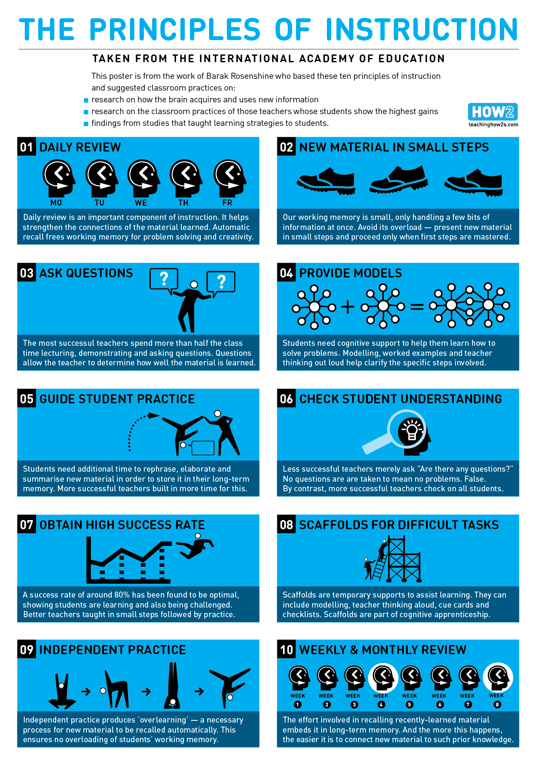
Date: February 2022
Review Date: July 2023

